OpenDICE (v2.1) User Manual
Lei He
lehe@loc.gov
1-202-707-8239

This version of OpenDICE implements the FADGI v2016. It extends the previous version of v2.0 to support object DICE target (the smaller size DICE target). In addition, the two negative targets (35mm and 4×5") now supports automatic ROI detection.
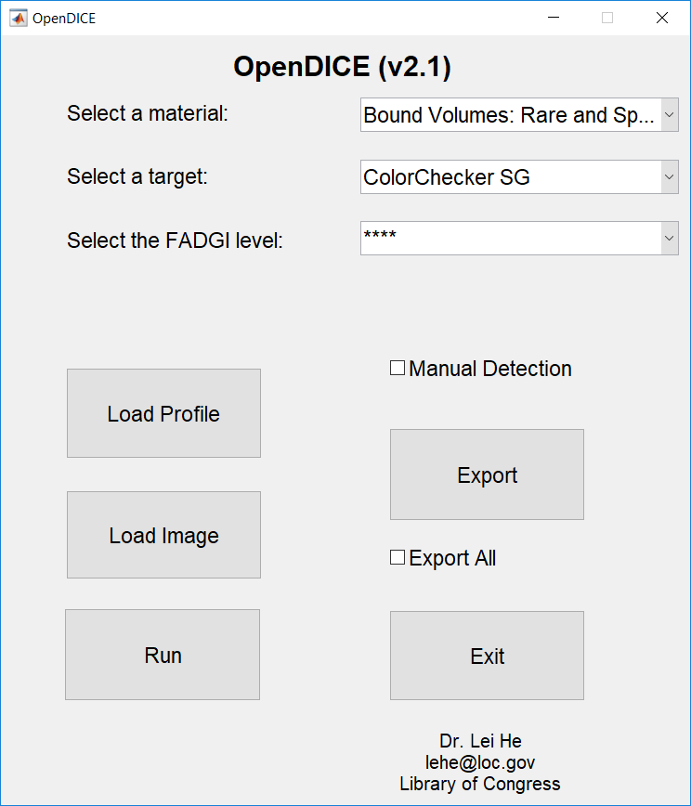
Figure 1. OpenDICE user interface

- In the interface (Figure 1), the default setting for the material is Bound Volumes: Rare and Special Materials. The default target is ColorChecker SG, and the default FADGI criteria is 4 star. Other materials include:
Bound Volumes: General Collections
Documents (Unbound): Manuscripts and Other Rare and Special Materials
Documents (Unbound): General Collections
Oversize Items: Maps, Posters, and Other Materials
Newspapers
Prints and Photographs
Paintings and Other Two-Dimensional Art (other than prints)
Photographic Transparencies: 35mm to 4"x5"
Photographic Transparencies: >4"x5"
Photographic Negatives: 35mm to 4"x5"
Photographic Negatives: > 4"x5"
X-ray Film: (Radiographs)
Printed Matter, Manuscripts, and Other Documents on Microfilm

For the target options, users may select:
ColorChecker SG
DICE
ObjectDICE(small)
NGT (manual)
IT8.7 (manual)
UTT (manual)
Negative Small 35mm
Negative Large 4x5

The default FADGI level for image quality assessment is 4 star, which may be changed to 3, 2, or 1 star. Note each time user change the material and target, the star level should be reselect as a confirmation.

- Once the user selects the material, a dialog box is shown to ask for the material configuration file, which specifies the FADGI criteria settings for different materials. A configuration file is provided (Figure 2).
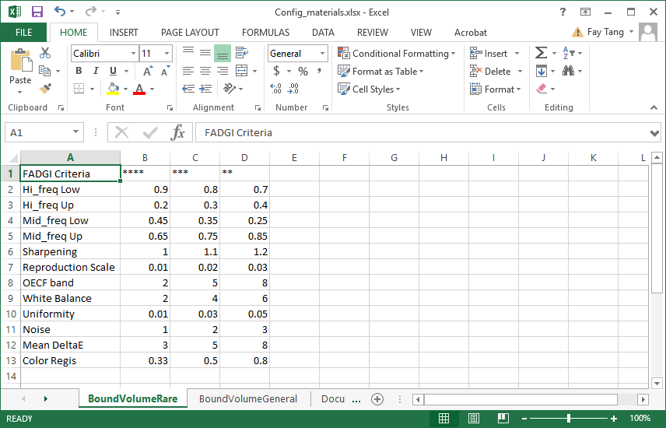
Figure 2. Material configuration file (Config_materials.xlsx) with FADGI v2016
- (1). Each time after material selection (together with the Excel configuration file), users also need to reselect the target and FADGI star level. In current version, OpenDICE supports only 8 different targets, which match with different materials. Briefly, the first 8 materials are supported by the first 6 targets. Those targets with a note “manual” after their names means manual selection of landmarks are necessary. More details will be shown later.
(2). User will load the target profile first according to the target selection. It should be an Excel file, with the measurements as the ground truth for color accuracy assessment (L*a*b*) and tonescale analysis (density), respectively. For example, a DICE profile and a Colorchecker SG profile are shown in Figure 3 and Figure 4.
(2). The profile format is strictly defined, with the L*, a*, b*, and D as the table head. The patches are listed from 1 to 30 (DICE), or from A1…A10 to N1…N10 (Colorchecker SG).
(3). Note that the DICE target has density measurements for its 12 gray patches (#10 - #21), and Colorchecker SG target has density measurements for its central 12 gray patches (#E5 - #J6).
(4). The profile must match with the selected target, otherwise an error message will be displayed. Then user may reselect either the profile or target.
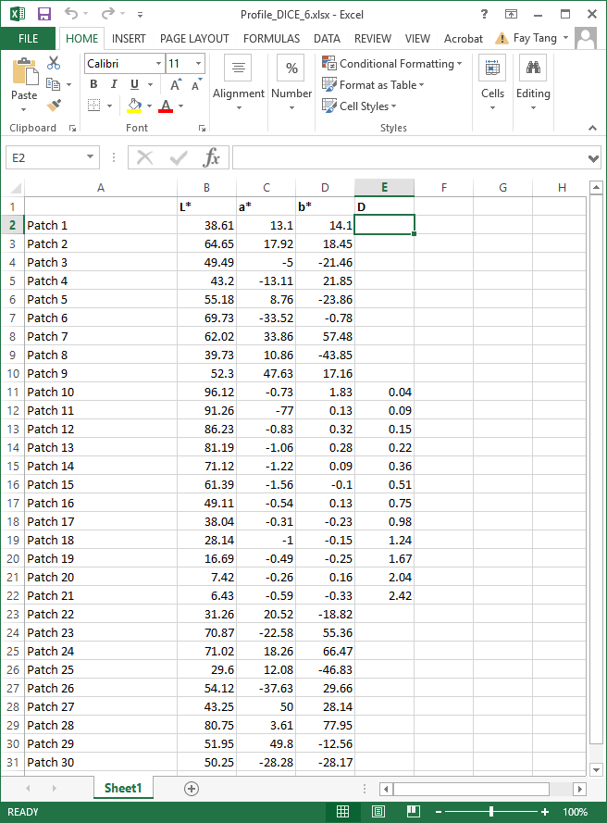
Figure 3. DICE target profile with the L*a*b* and density (D) measurements

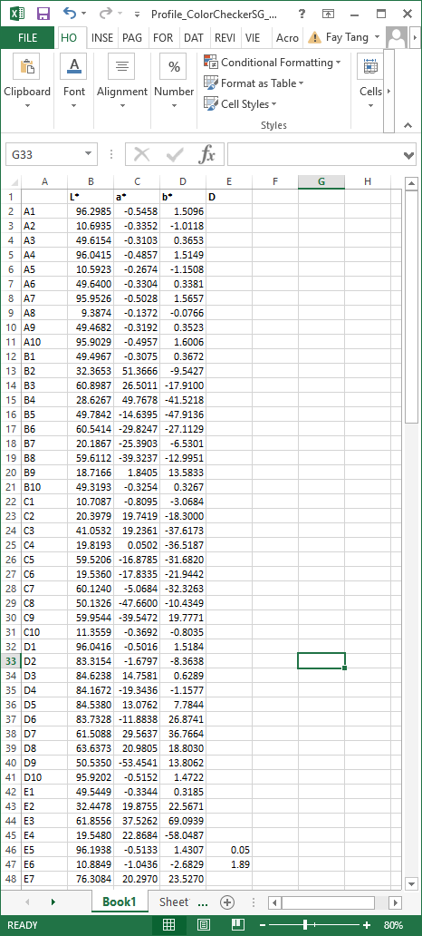
Figure 4. Colorchecker SG target profile with the L*a*b* and density (D) measurements

- After loading the profile, user may import the target image for quality assessment. Similarly, the image must match with the target. Otherwise an error message will be display for re-selection. With the current version, OpenDICE support only well scanned images with tilt angle less than 5°, i.e., no automatic rotation or adjustment is applied to the input image.

- Once the image is loaded, the regions of interest (ROI) on the image will be automatically identified, as shown with the rectangles. User may resize or drag the rectangles for minor location adjustment. If the ROI are far away from the ideal regions, manual selection is suggested, i.e., user check the Manual Detection option and load the image again.
Note that manual detection generally provides faster and more accurate ROI identification, with the user interaction. User must click the four corner points (for DICE targets and Negative Large 4x5) or cross points (for Colorchecker SG, UTT, and Negative Small 35mm) in a clockwise manner (double click is needed for the last click on point 1 when finish the loop), see Figure 5.
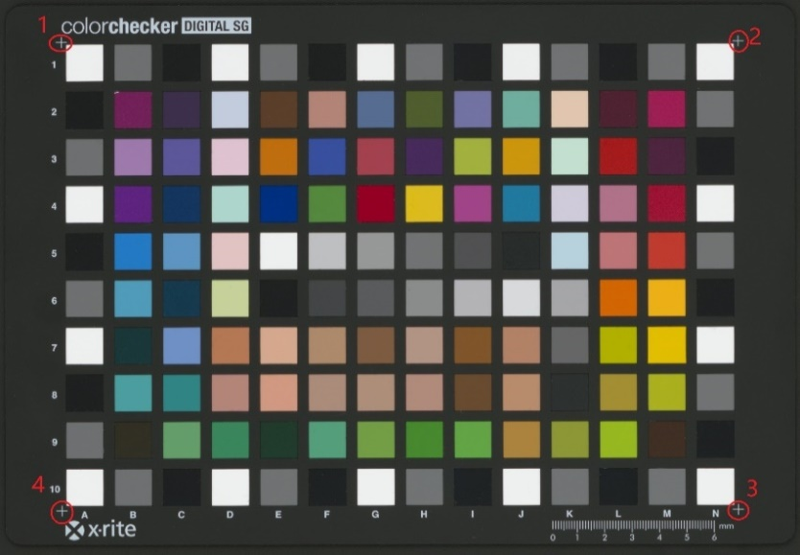
ColorChecker SG target manual selection
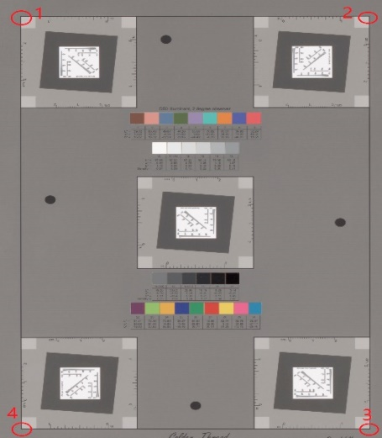 DICE target manual selection

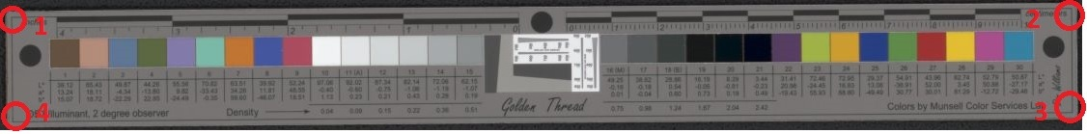
ObjectDICE target manual selection

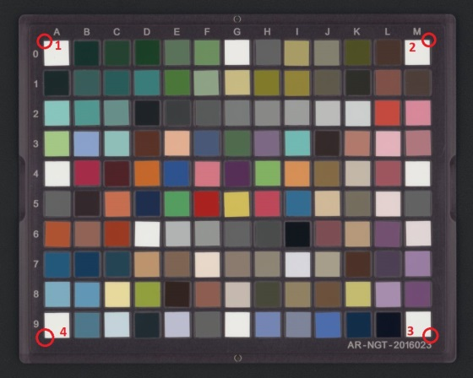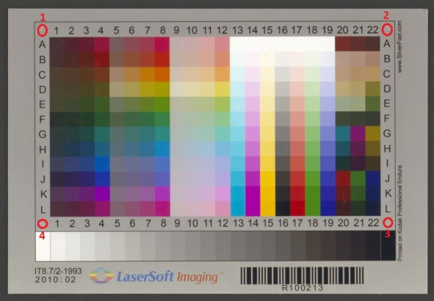
NGT target manual selection IT8.7 target manual selection
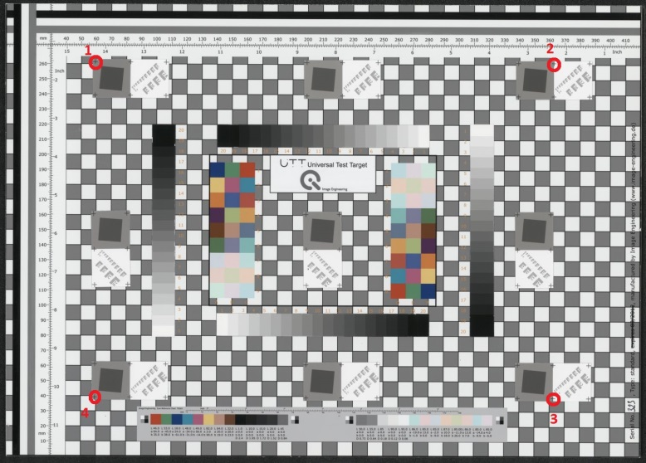
UTT target manual selection
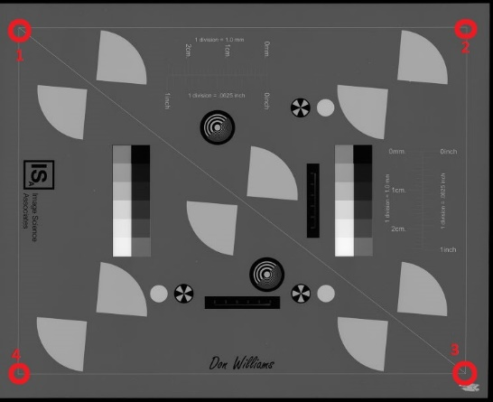 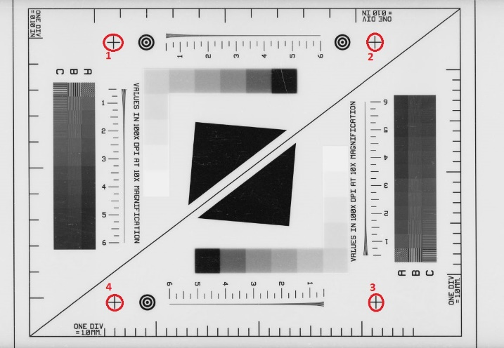
Negative large 4×5" Negative Small 35mm
Figure 5. Landmark points for user manual selection to identify the ROI

- Once the ROI are identified, user will see the images overlapped with a set of rectangles, see Figure 6. In this identification process, user cannot click any buttons on the interface. Again, user may be drag or resize the rectangles for more accurate location. Depending on the image size, this step may take a couple of minutes to identify the ROI on Colorchecker SG images. In such cases, we recommend Manual Detection option before loading the image.
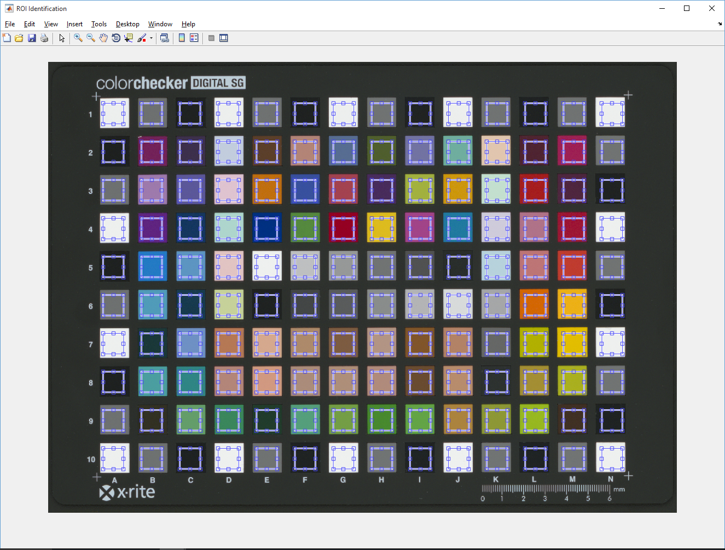
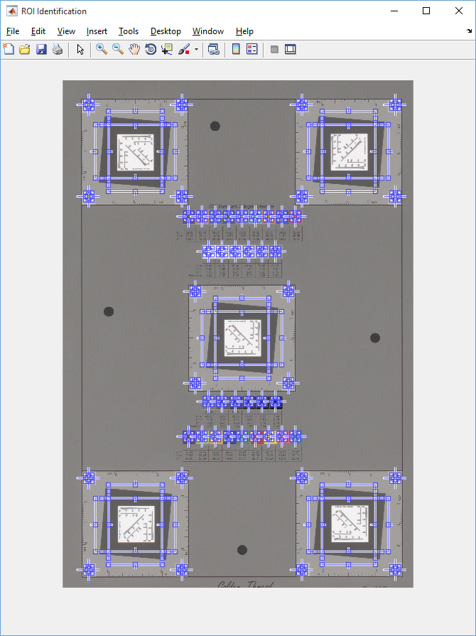
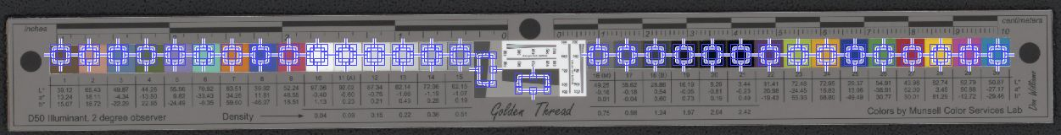
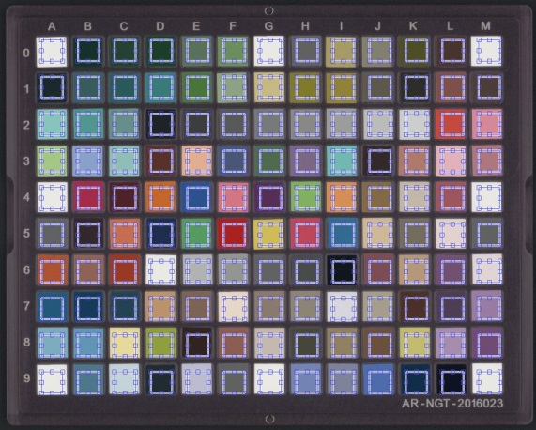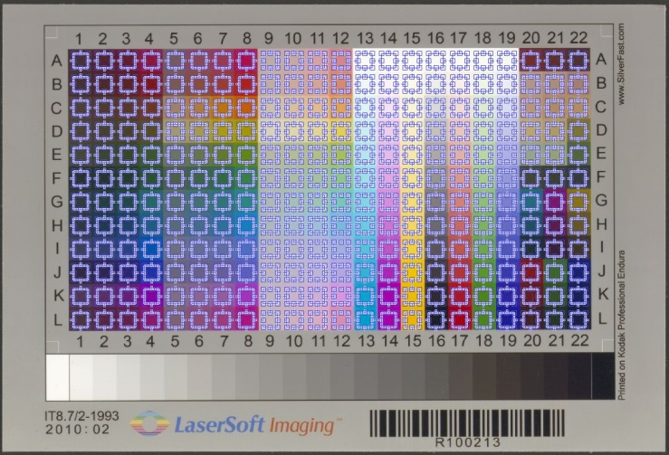
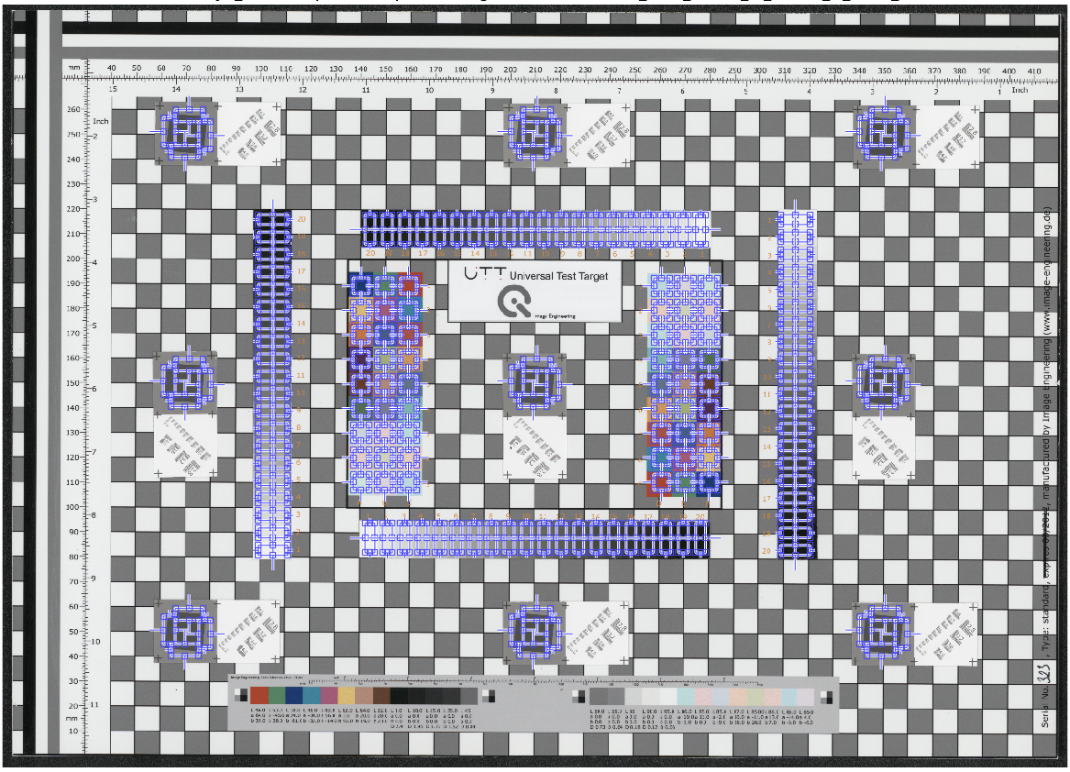

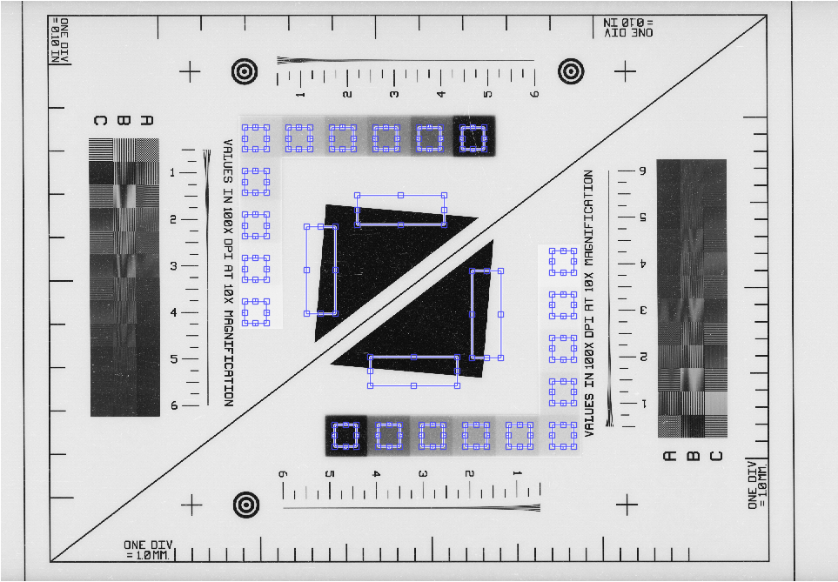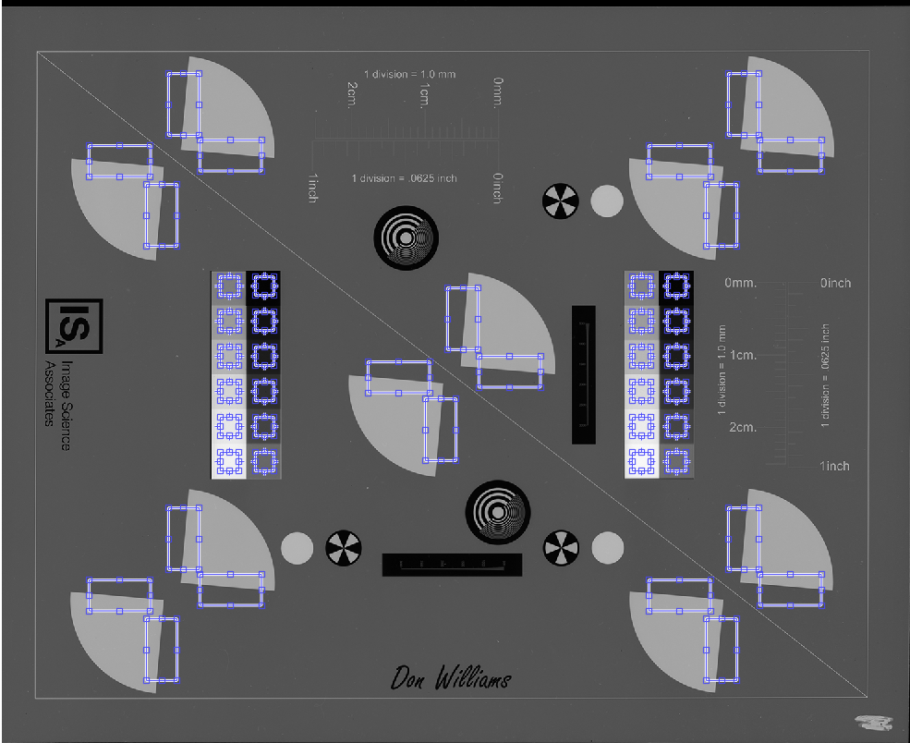
Figure 6. ROI identification for Colorchecker SG, DICE, Object DICE, NGT, IT8.7, UTT, Negative Small 35mm, and Negative Large 4×5" target images.

- User confirm the ROI are acceptable, then click Run button to start assessment. The assessment results are displayed on two (Colorchecker SG target) or three (DICE target) windows. For the Colorchecker SG target, the first window displays color accuracy analysis results and the second window presents tonescale analysis results. DICE target images have the third window for resolution analysis results.

(1). Color accuracy window consists of four tabs: Luminance, Delta E 2000, Color Registration Accuracy, and Summary.
Luminance tab shows the difference between the aim (ground truth from the measurements) and the actual image values for all patches, as shown in Figure 7.
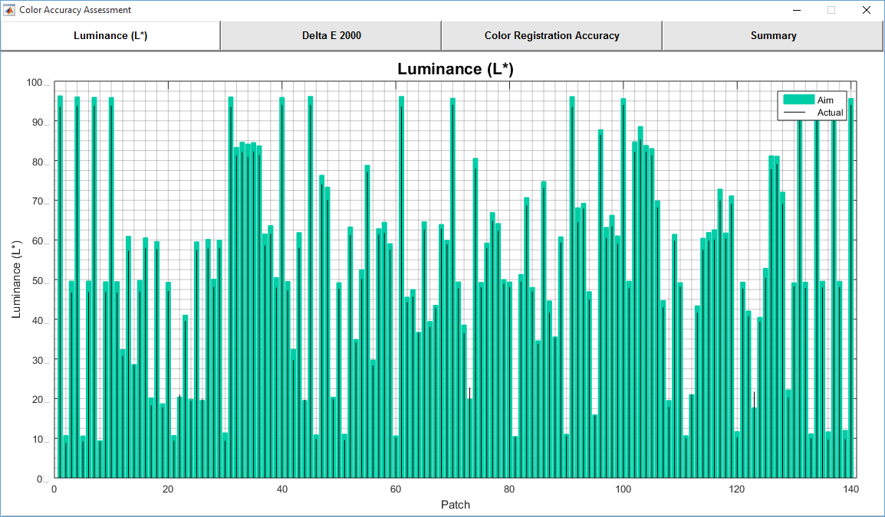
Figure 7. Luminance tab in Color Accuracy Analysis window

Delta E 2000 tab shows the ΔE2000 between the ground truth and the actual image values for all patches, as shown in Figure 8. The vertical black lines with black dots represent the actual ΔE2000 values, and the vertical red lines with red dots show the actual ΔE2000(a*b*) values. The horizontal magenta line shows the maximum upper limit for ΔE2000 according to the user FADGI level selection. Similarly, the horizontal blue line shows the mean upper limit for ΔE2000. The horizontal black line shows the actual mean ΔE2000, and the horizontal green line shows the actual median ΔE2000.
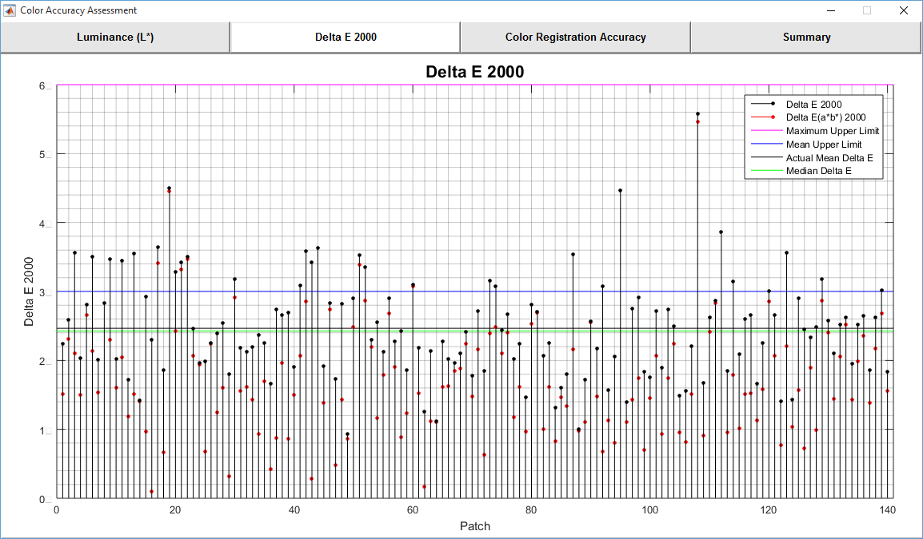
Figure 8. Delta E 2000 tab in Color Accuracy Analysis window

Color Registration Accuracy tab is not applicable to Colorchecker SG target. Figure 9 shows an example of DICE target.
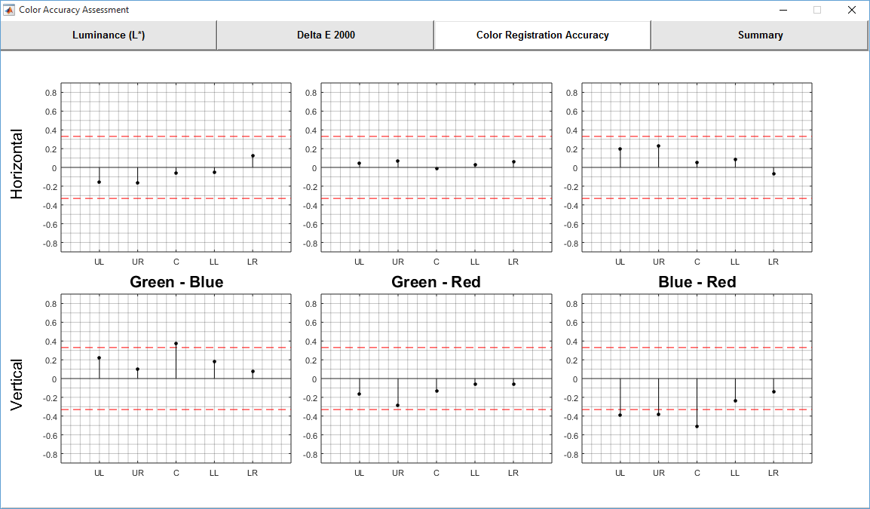
Figure 9. Color Registration Accuracy tab in Color Accuracy Analysis window (only for DICE target)

Summary tab shows the detail results (value) according to the FADGI guideline performance level (lower limit and upper limit), see Figure 10.
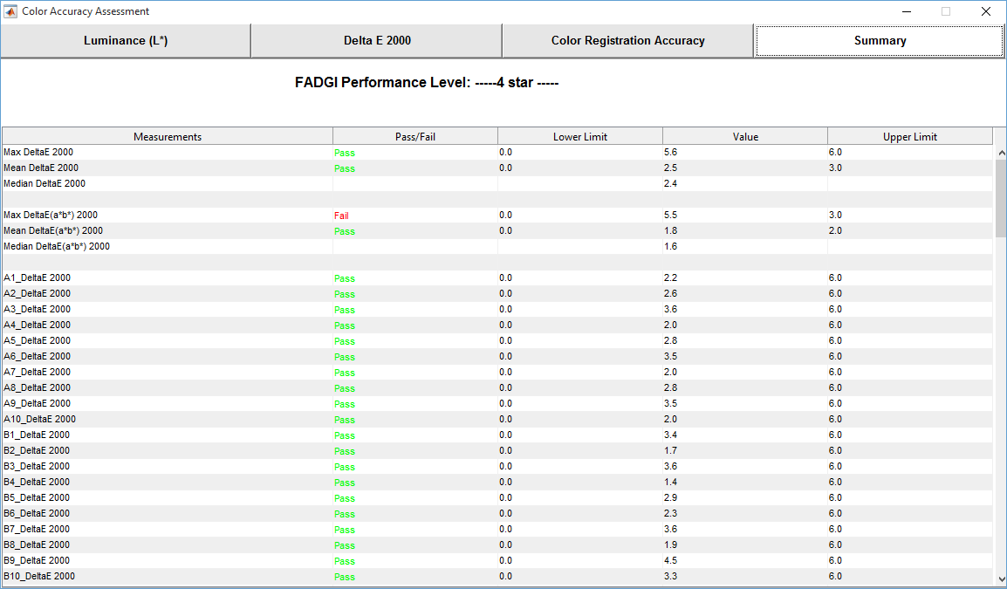
Figure 10. Summary tab in Color Accuracy Analysis window

(2). Tonescale analysis window consists of four tabs: OECF Curves, Difference to Aim, White Balance, Uniformity, Noise, and Summary.

OECF tab shows the OECF curves for RGB and luminance components, as shown in Figure 11. User may change the gamma, gain, and offset to adjust the curves in order to fit them into the range defined by the current FADGI level (magenta curves).
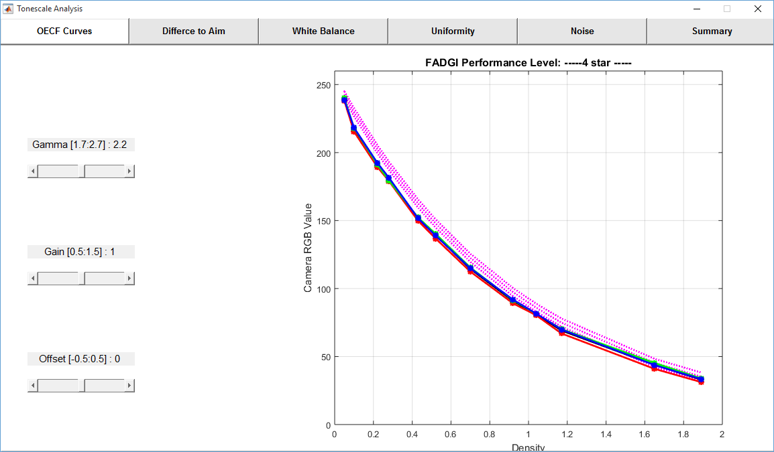
Figure 11. OECF Curves tab in Tonescale Analysis window

Difference to Aim tab shows error of the OECF curves, and the ideal range defined by the current FADGI level (magenta curves), see Figure 12.
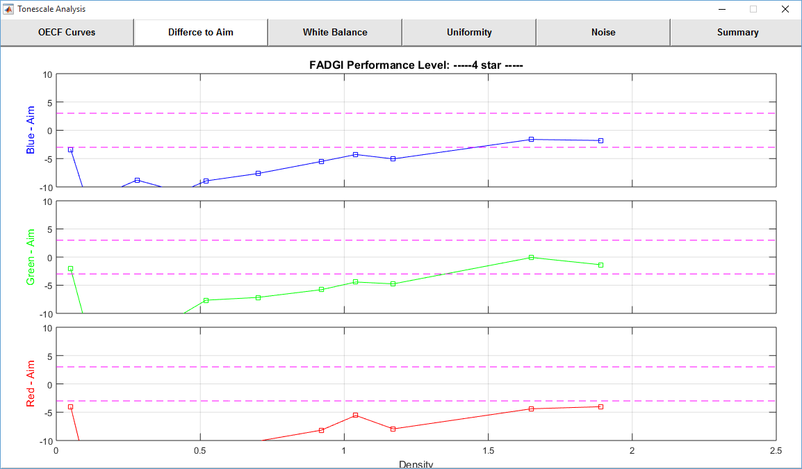
Figure 12. Difference to Aim tab shows the OECF curve errors in Tonescale Analysis window

White Balance tab shows white balance error (blue-red, green-red, and green-blue) of the neutral patches, and the ideal range defined by the current FADGI level (magenta curves), see Figure 13.
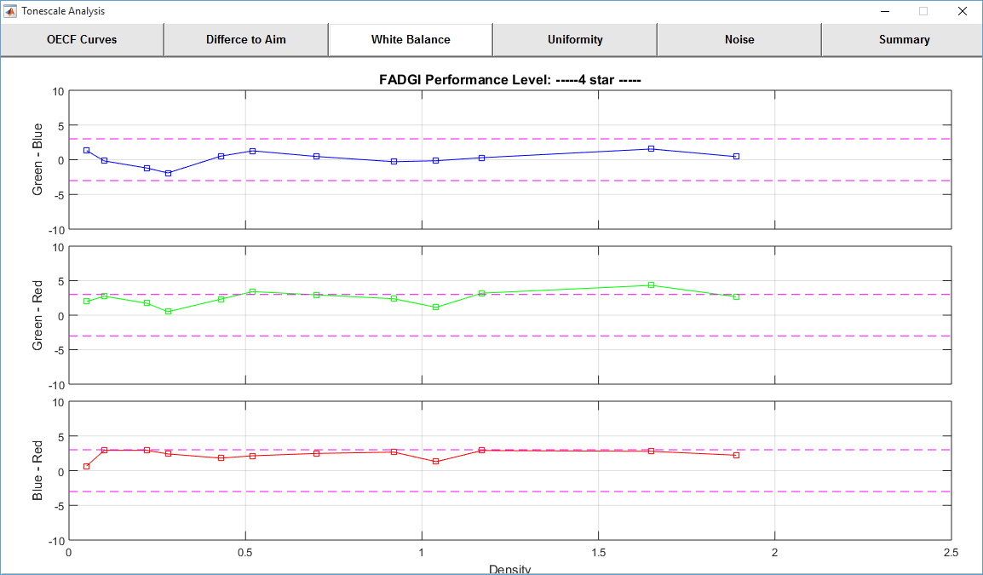
Figure 13. White Balance tab shows the white balance errors in Tonescale Analysis window

Uniformity assessment is not applicable to Colorchecker SG target. Figure 14 shows an example of DICE target.
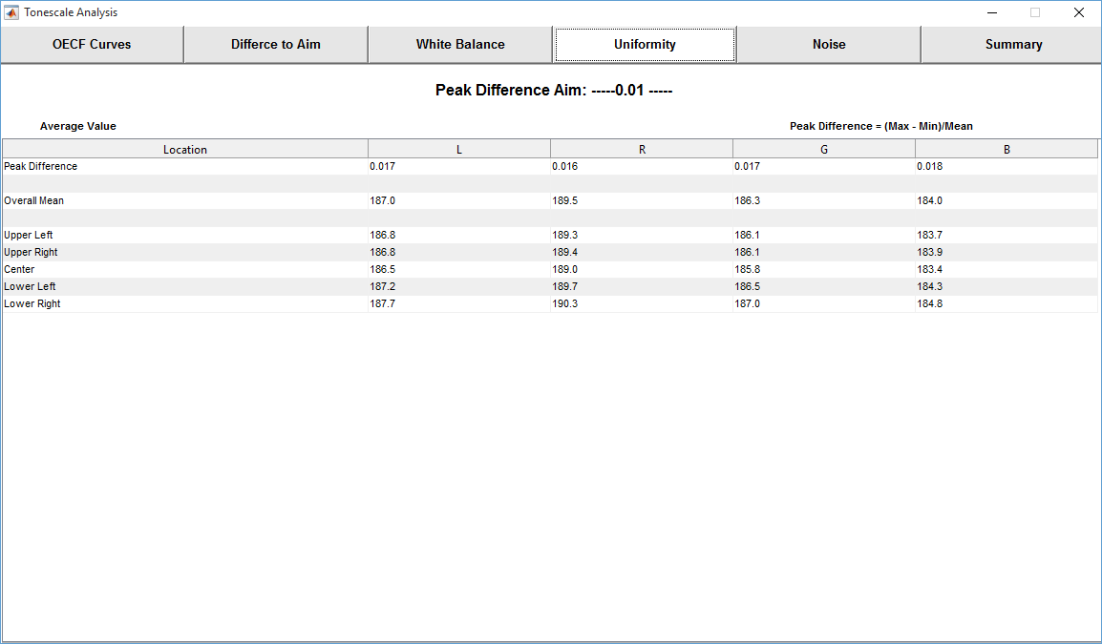
Figure 14. Uniformity tab shows the illuminance uniformity error in Tonescale Analysis window (only for DICE target)

Noise tab shows the noise level for the neutral patches, see Figure 15.
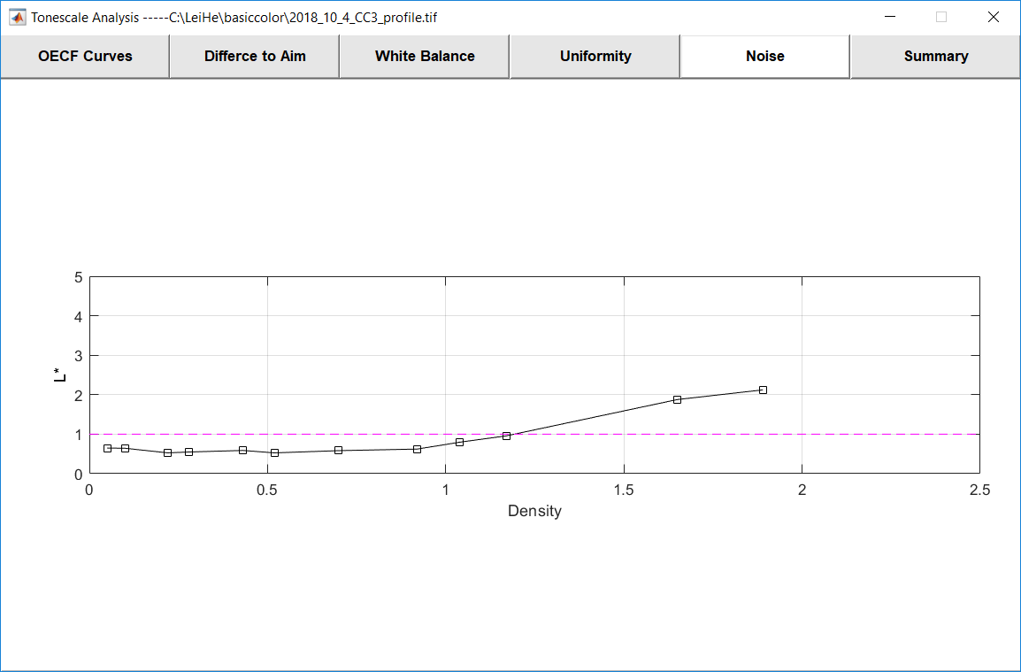
Figure 15. Noise tab shows the noise levels in Tonescale Analysis window

Summary tab shows the detail results (value) according to the FADGI guideline performance level (lower limit and upper limit), see Figure 16.
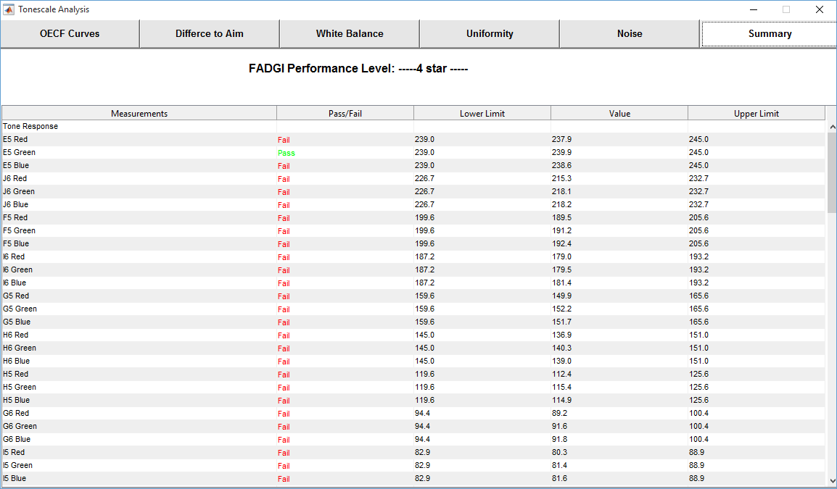
Figure 16. Summary tab shows the tonescale analysis results

(3). Specifically for DICE, UTT, and negative targets, there is a resolution analysis window which consists of nine tabs: Efficiency, SFR (10%), SFR (50%), Center, Upper Left, Upper Right, Lower Left, Lower Right, and Summary.

Efficiency tab shows the average sampling efficiency for red, green, and blue components, see Figure 17 and Figure 18.
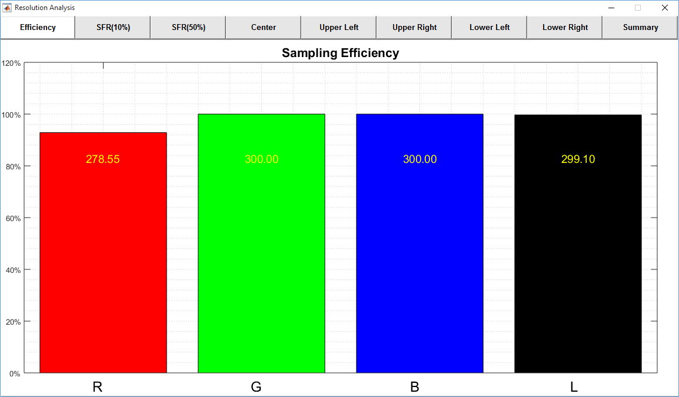
Figure 17. Efficiency tab shows the sampling efficiency values in resolution analysis window

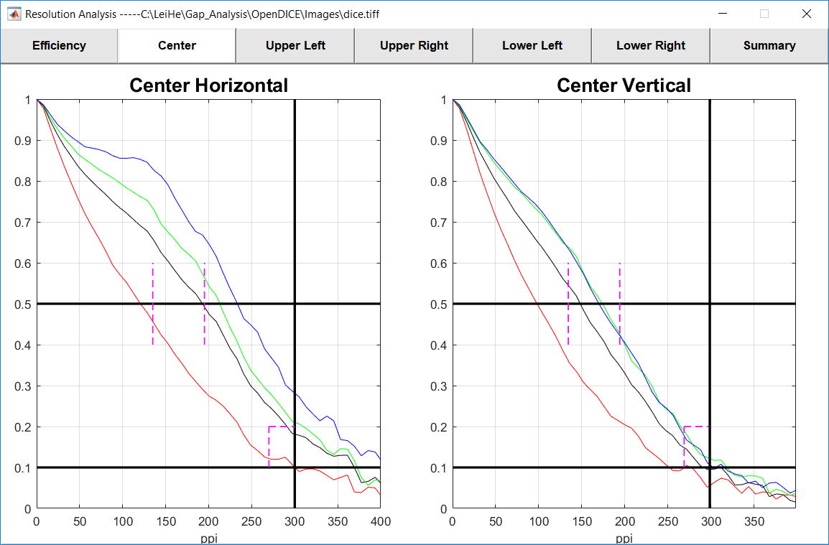
Figure 18. Sample SFR curve tab shows the frequency response at high and middle resolutions

- With these results, user may click the Export button to write all the results to an Excel file as the results. The file will be saved in the same folder as that of the image, with an extension of the FADGI star level. Note that Microsoft Excel is required in order to write the results.

