OpenDICE (v2.6) User Manual
Lei He
lehe@loc.gov
1-202-707-8239

This version of OpenDICE implements the FADGI v2016. It changes the flow of material and target selection based on the previous version of v2.5. This version adds the bar code support to the FADGI 19264 target. It also changes the vertical and horizontal orientation assessment of the SFR curves following the ISO standard definition of the edge orientations.
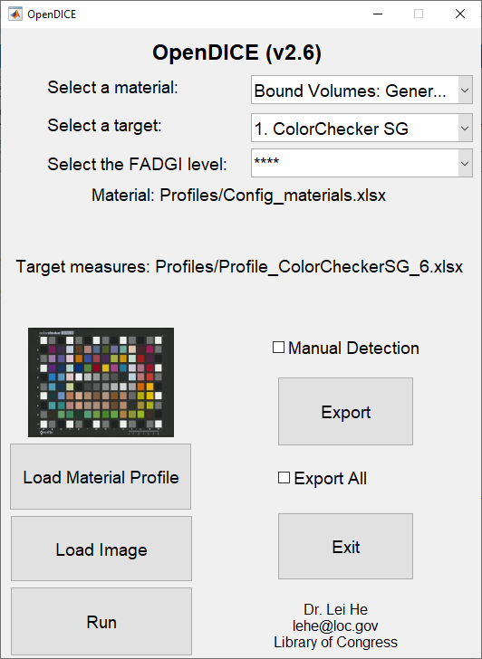
Figure 1. OpenDICE user interface

Step 1. In the interface (Figure 1), the default setting for the material is Bound Volumes: General Collections. The default target is ColorChecker SG, and the default FADGI criteria is 4 star. The software first locates the default material setting profile (the FADGI criteria settings for different materials), e.g., Config_materials.xlsx, and the measurements of the default target (generic or true measurements of the patch CIE Lab values and density values), e.g., Profile_ColorCheckerSG_6.xlsx, from the default Profiles folder. If these two files can be correctly located, their names will be displayed on the interface window. Otherwise, the window shows blank spaces. Users need to click the Load Material Profile button to locate the material setting profile and use the Select a target menu to locate the target measurements.

Other materials include:
Bound Volumes: Rare and Special Materials
Documents (Unbound): General Collections
Documents (Unbound): Manuscripts and Other Rare and Special Materials
Oversize Items: Maps, Posters, and Other Materials
Newspapers
Prints and Photographs
Paintings and Other Two-Dimensional Art (other than prints)
Photographic Transparencies: 35mm to 4"x5"
Photographic Transparencies: >4"x5"
Photographic Negatives: 35mm to 4"x5"
Photographic Negatives: > 4"x5"
X-ray Film: (Radiographs)
Printed Matter, Manuscripts, and Other Documents on Microfilm

For the target options, users may select:
1. ColorChecker SG
2. DICE
3. ObjectDICE(small)
4. FADGI 19264
5. FADGI 19264 Commercial
6. NGT (manual)
7. DT-NGT
8. IT8.7/2 (manual)
9. UTT
10. Negative/Positive Small 35mm
11. Negative Large 4x5
12. Negative Small 35mm 2
13. Negative Middle 120x120
14. IT8.7/1 (manual)

The default FADGI level for image quality assessment is 4 star, which may be changed to 3, 2, or 1 star. Note each time user change the material and target, the star level should be reselect as a confirmation.

Step 2. Users start with the material selection by clicking the button Select a material, a warning box is shown to ask for the material configuration file if the window shows blank space on the material profile, i.e., no default material setting profile is located in the beginning. A configuration file is provided (Figure 2). If users do not need to change the material, then they can skip this step.
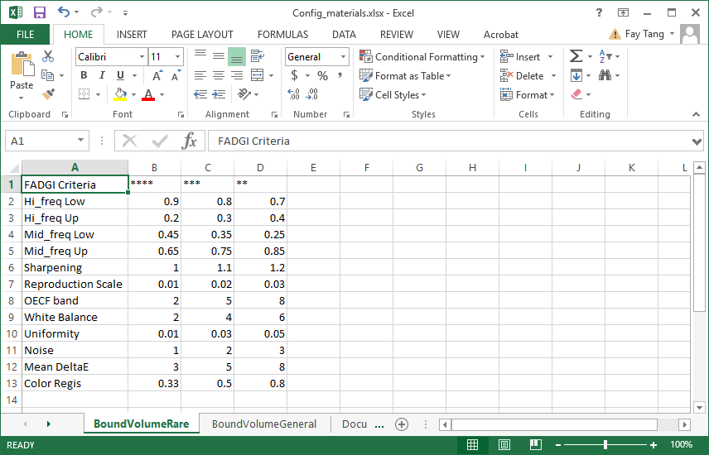
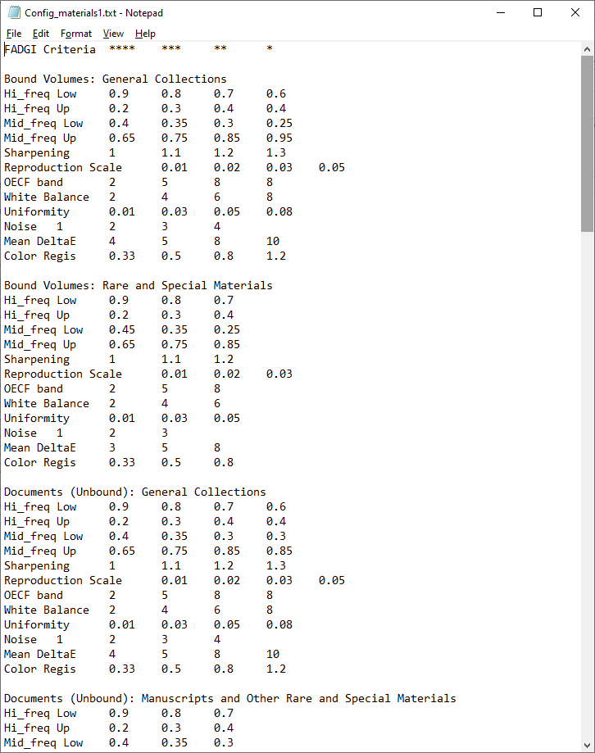
Figure 2. Material configuration file (Config_materials.xlsx and Config_materials.txt) with FADGI v2016
Step 3. (1). After the material selection, users can select the target and FADGI star level if they are different from the default. In current version, OpenDICE supports 12 different targets, which match with different materials. Briefly, the first 8 materials are supported by the first 8 targets. Those targets with a note “manual” after their names means manual selection of landmarks are necessary. More details will be shown later.
(2). User will load the target profile first according to the target selection. It should be an Excel file, with the measurements as the ground truth for color accuracy assessment (L*a*b*) and tonescale analysis (density), respectively. For example, a DICE profile and a Colorchecker SG profile are shown in Figure 3 and Figure 4.
(2). The profile format is strictly defined, with the L*, a*, b*, and D as the table head. The patches are listed from 1 to 30 (DICE), or from A1…A10 to N1…N10 (Colorchecker SG).
(3). Note that the DICE target has density measurements for its 12 gray patches (#10 - #21), and Colorchecker SG target has density measurements for its central 12 gray patches (#E5 - #J6).
(4). The profile must match with the selected target, otherwise an error message will be displayed. Then user may reselect either the profile or target.

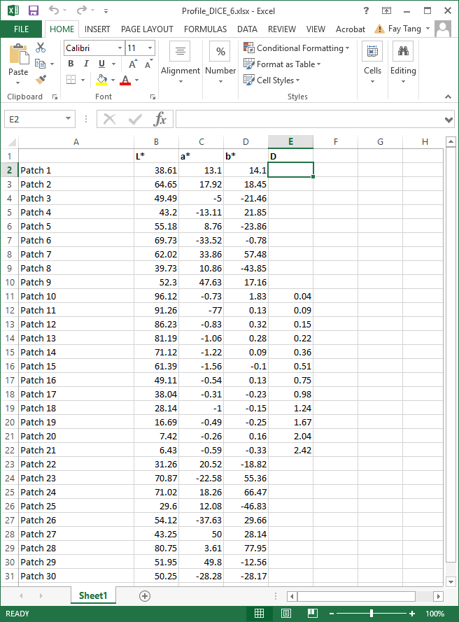

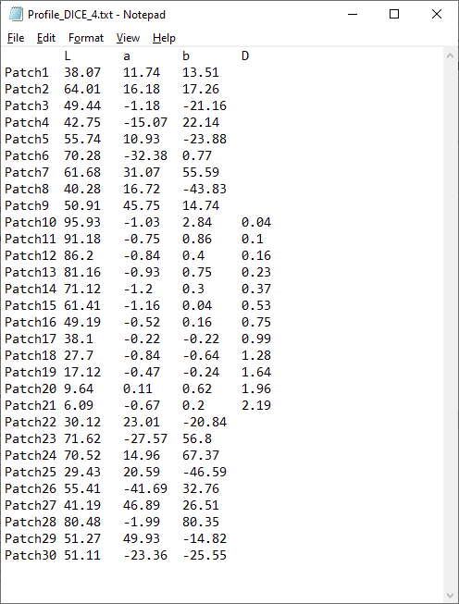
Figure 3. DICE target profile with the L*a*b* and density (D) measurements (Excel and text files)

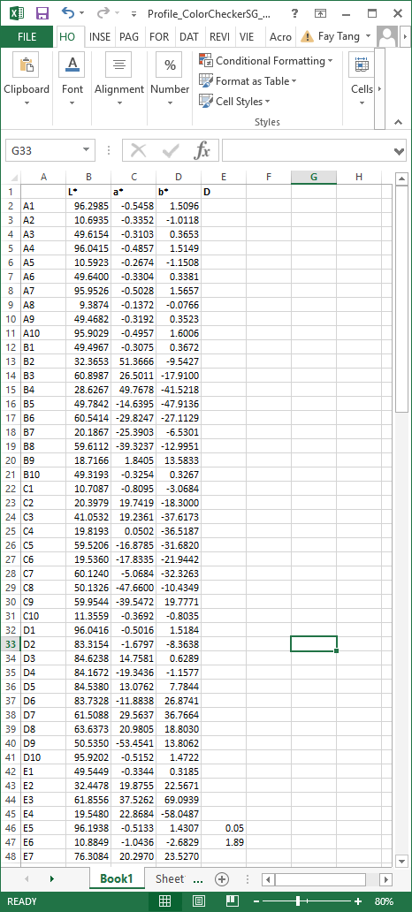
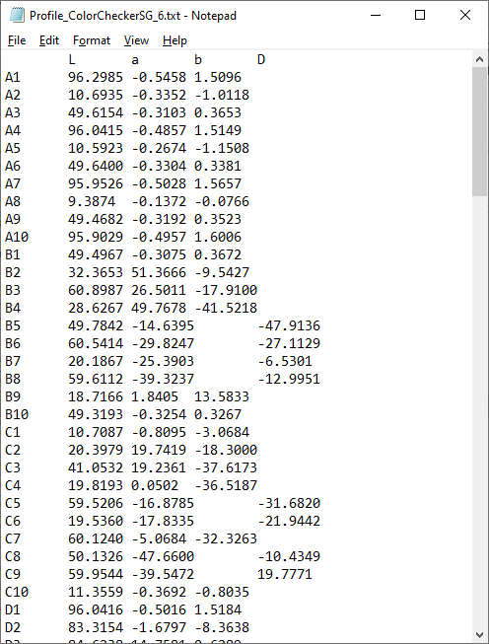
Figure 4. Colorchecker SG target profile with the L*a*b* and density (D) measurements (Excel and text files)

Each time after the target selection, the measurement file needs to be uploaded again as a confirmation for this target.

Step 4. After the material, target, and star level selection, users may import the target image for quality assessment by clicking the button Load Image. The image must match with the target. Otherwise an error message will be displayed for re-selection. With the current version, OpenDICE supports only well scanned images with tilt angle less than 5°, i.e., no automatic rotation or adjustment is applied to the input image.

Step 5. Once the image is loaded, the regions of interest (ROI) on the image will be automatically identified, as shown with the rectangles. User may drag the rectangles for minor location adjustment. If the ROI are far away from the ideal regions, manual selection is suggested, i.e., user check the Manual Detection option and load the image again.
Note that manual detection generally provides faster and more accurate ROI identification, with the user interaction. User must click the four corner points (for DICE targets and Negative Large 4x5) or cross points (for Colorchecker SG, UTT, and Negative Small 35mm) in a clockwise manner (double click is needed for the last click on point 1 when finish the loop), see Figure 5.
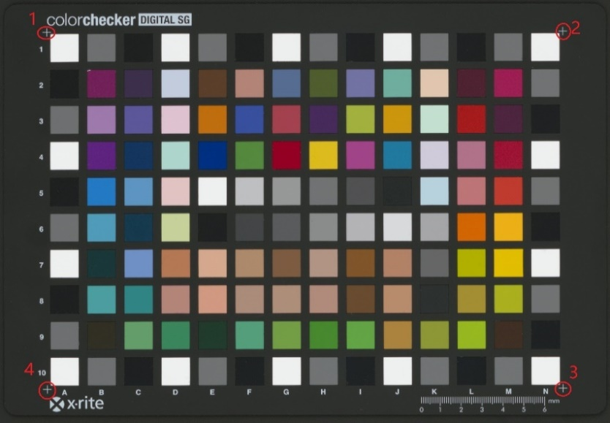
- ColorChecker SG target manual selection
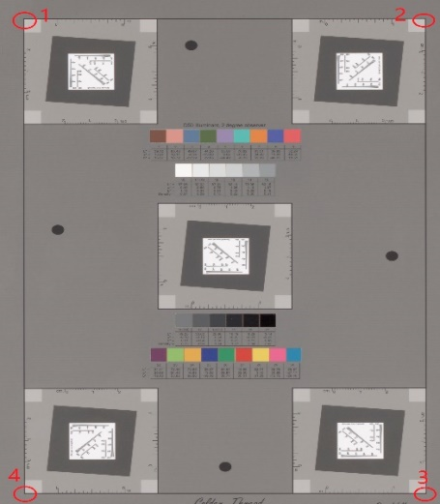
- DICE target manual selection

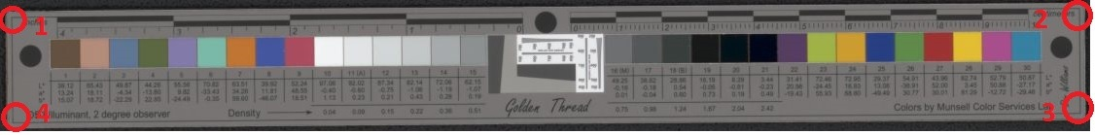
- ObjectDICE target manual selection
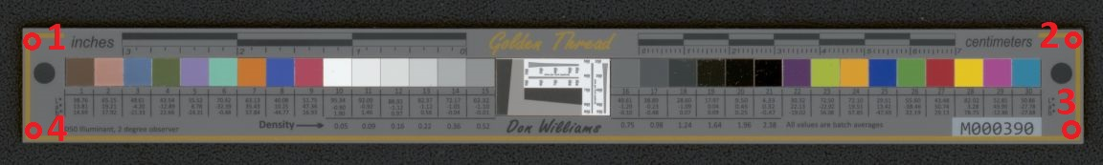
3. ObjectDICE target manual selection
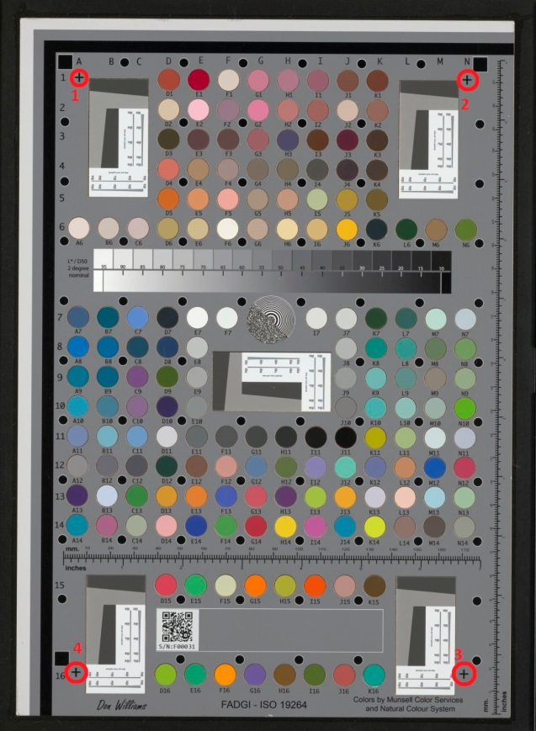
4. FADGI 19264 target manual selection 5. FADGI 19264 Commercial target selection
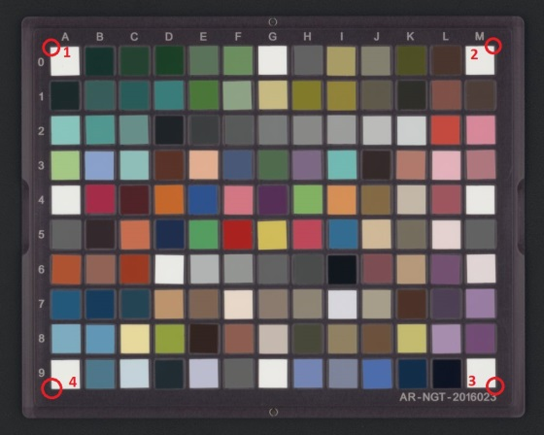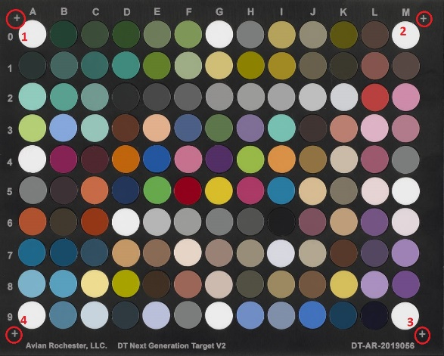
- NGT target manual selection 7. DT-NGT target manual selection
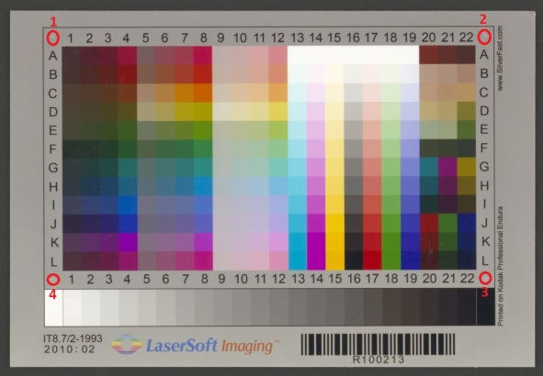
- IT8.7 (/1 and /2) targets manual selection
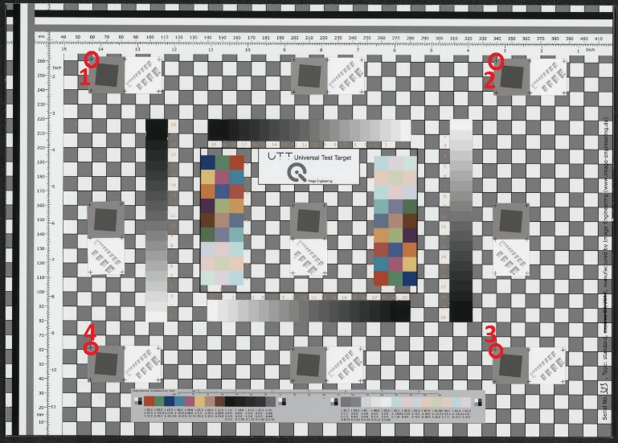
- UTT target manual selection
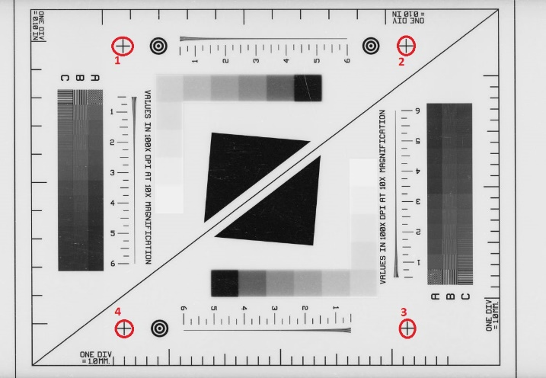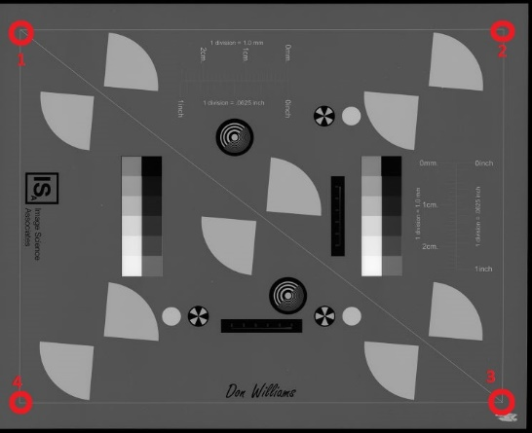
10. Negative Small 35mm 11. Negative large 4×5"
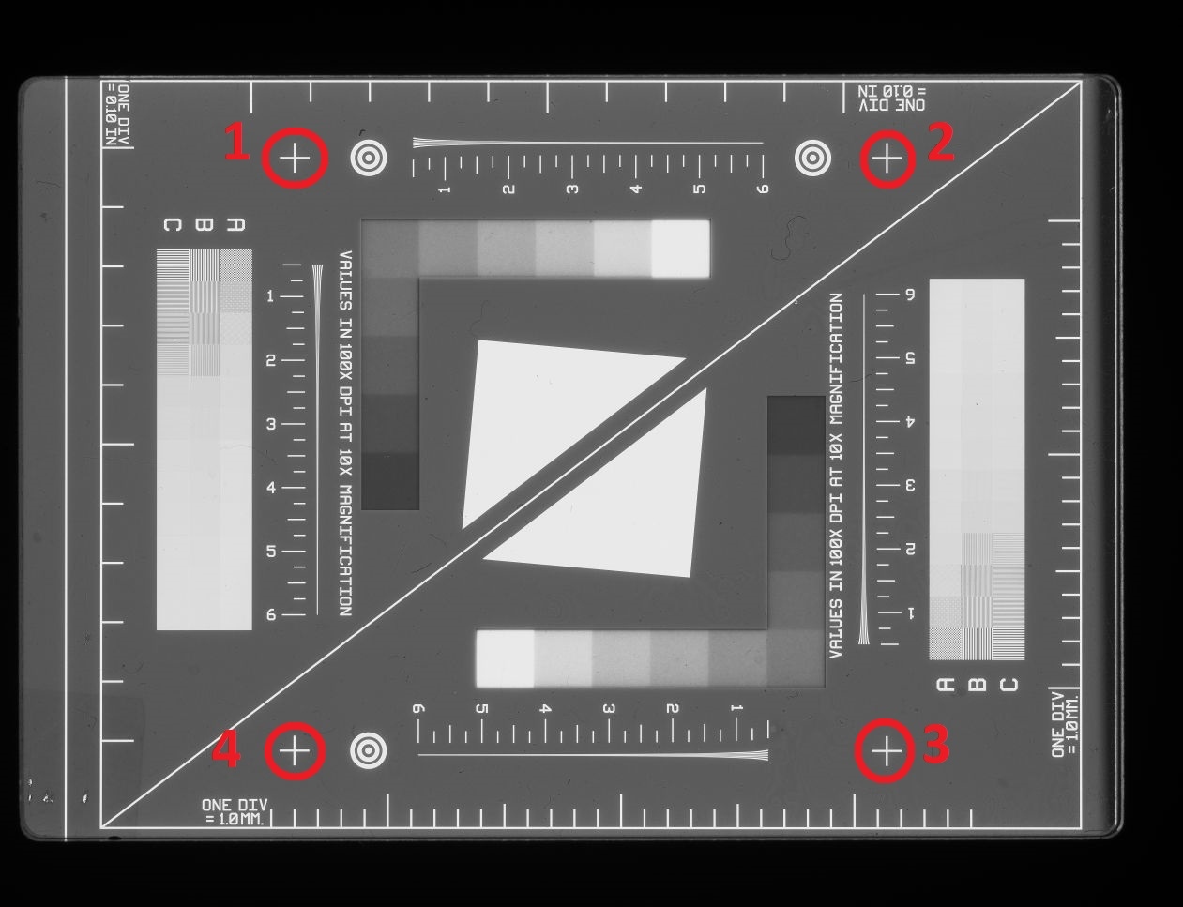 11. Positive Small 35mm
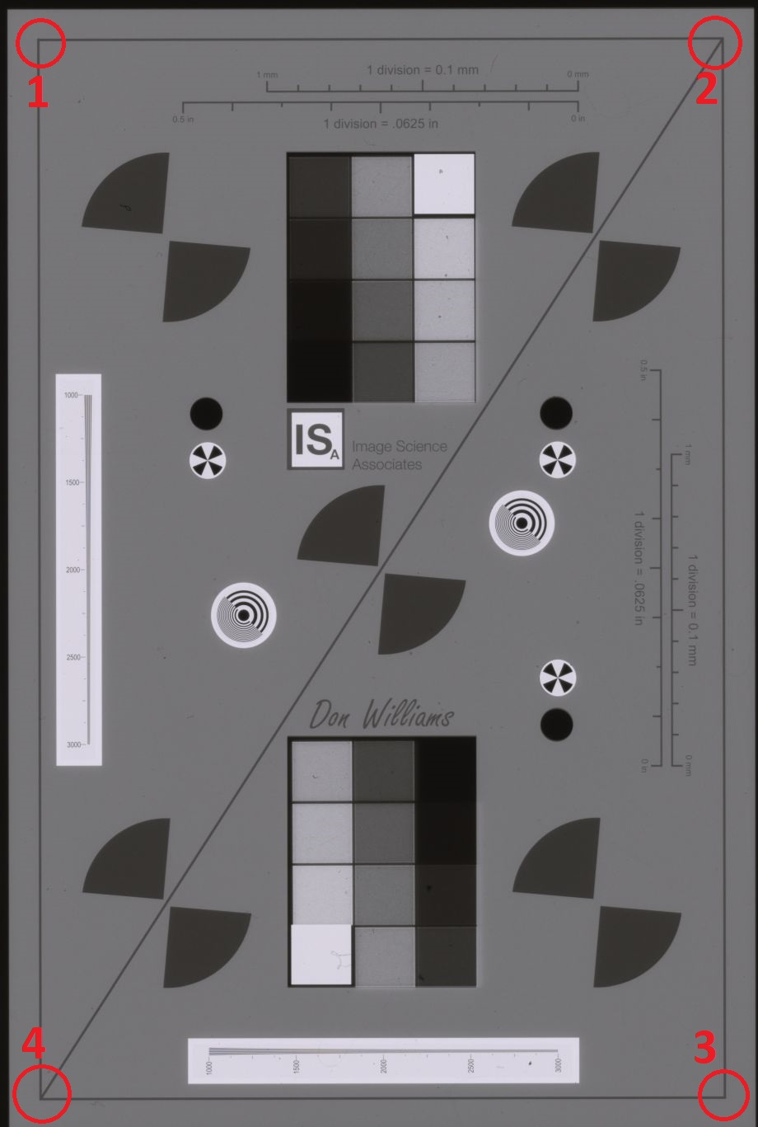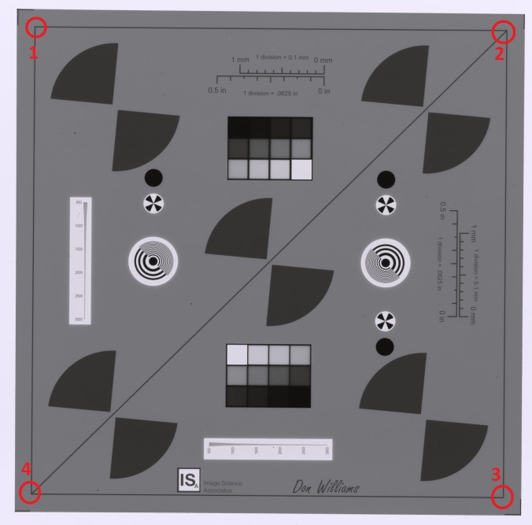
12. Negative Small 35mm_2 13. Negative middle 120
Figure 5. Landmark points for user manual selection to identify the ROI

Once the ROI are identified, users will see the images overlapped with a set of rectangles, see Figure 6. In this identification process, users cannot click any buttons on the interface. Again, user may be drag the rectangles for more accurate location. Depending on the image size, this step may take a couple of minutes to identify the ROI on Colorchecker SG images. In such cases, we recommend Manual Detection option before loading the image.
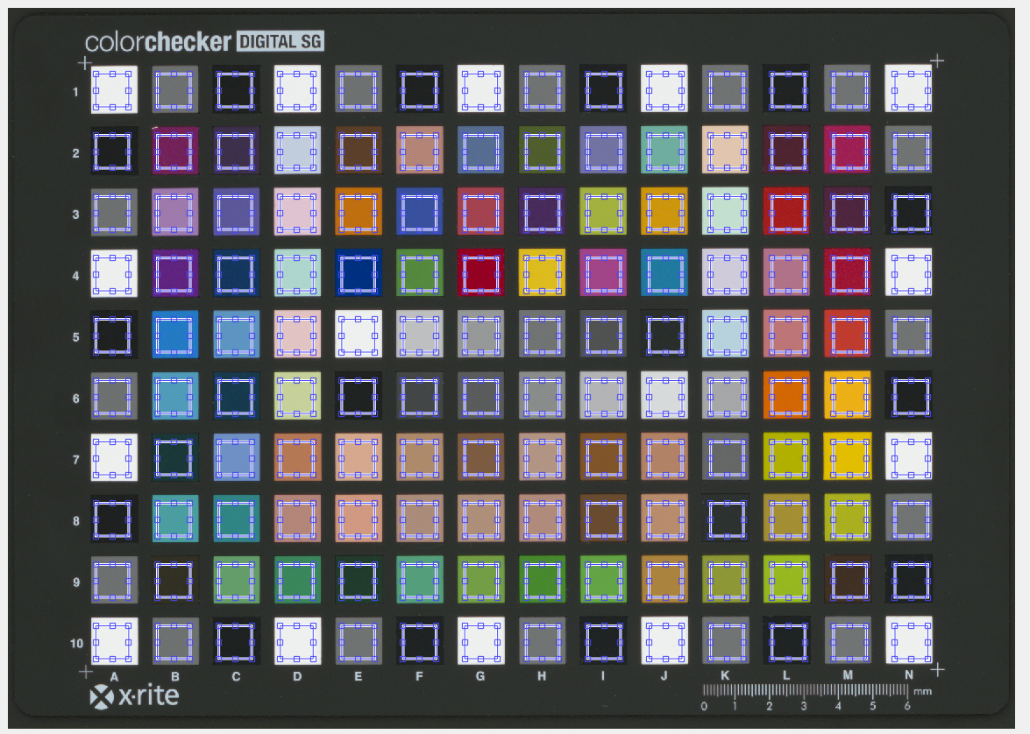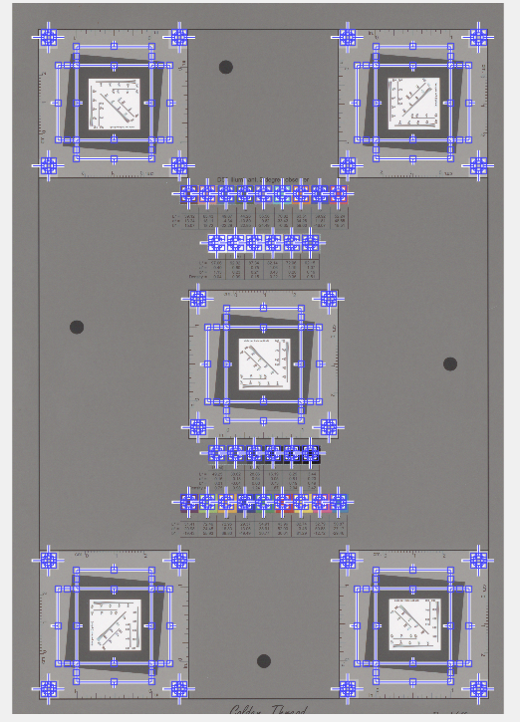
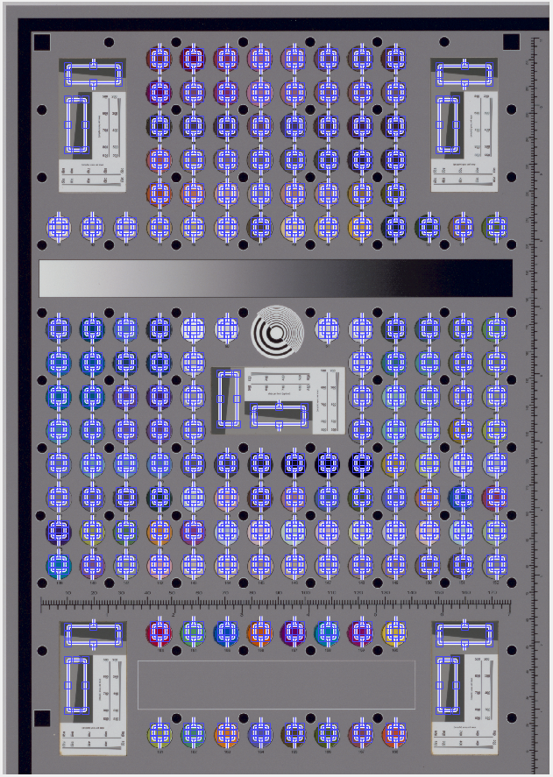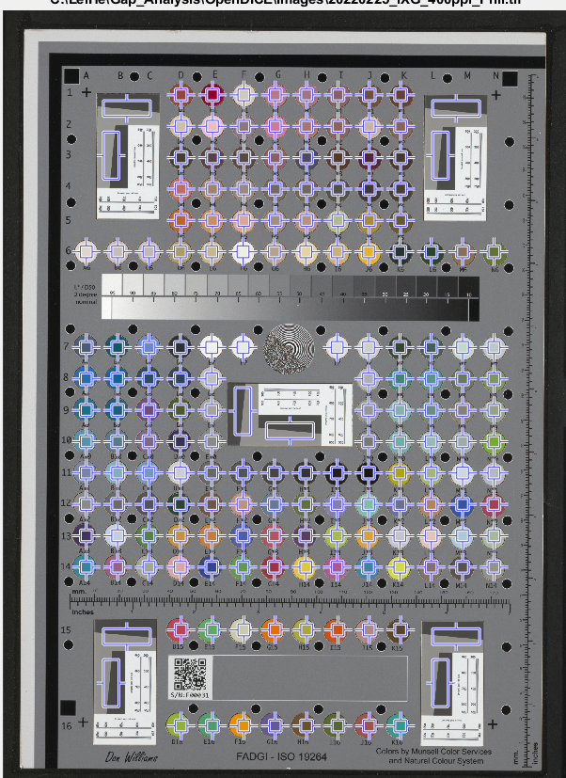
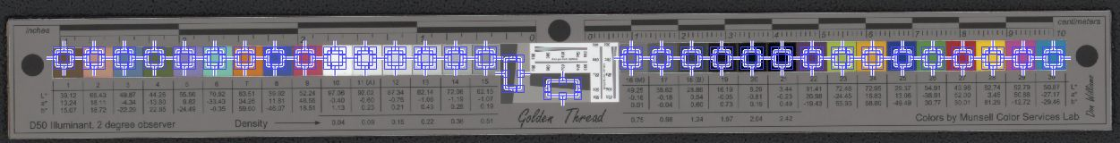
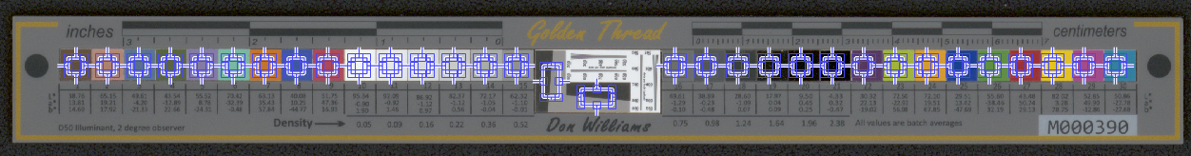
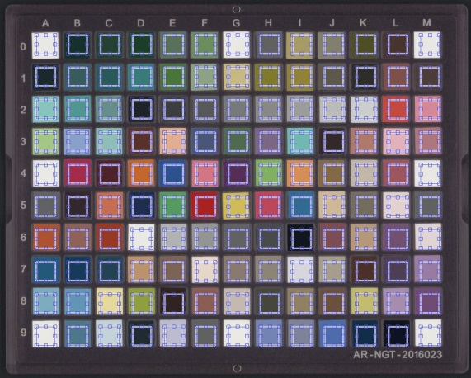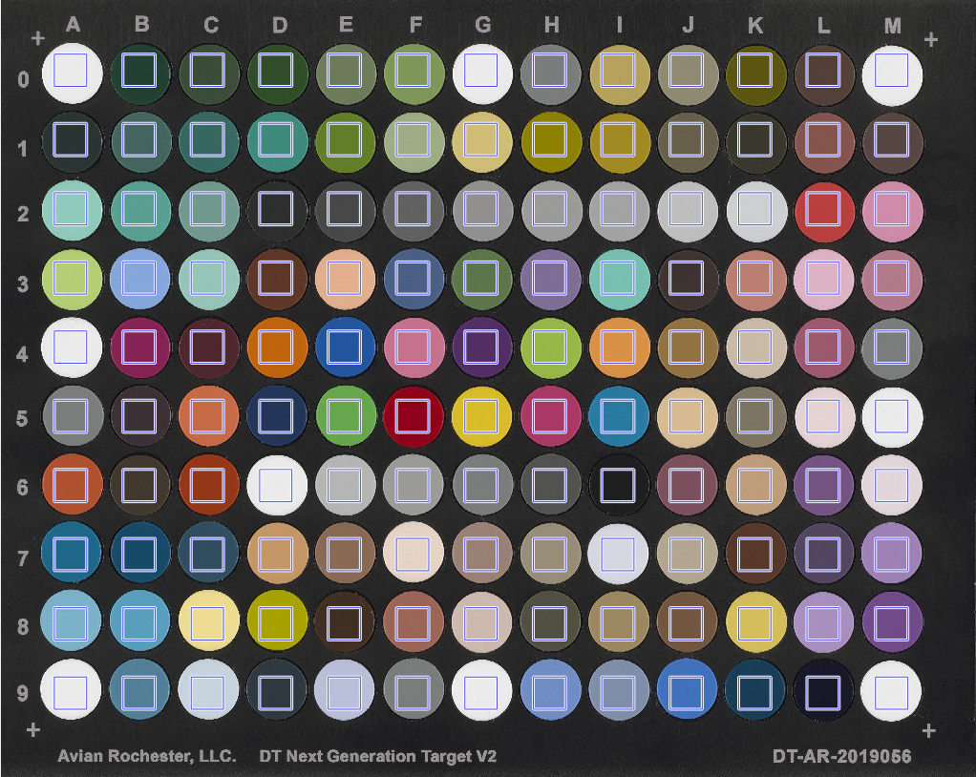
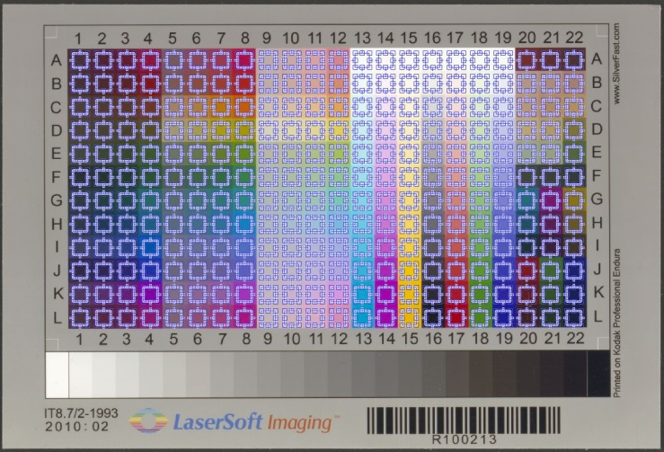
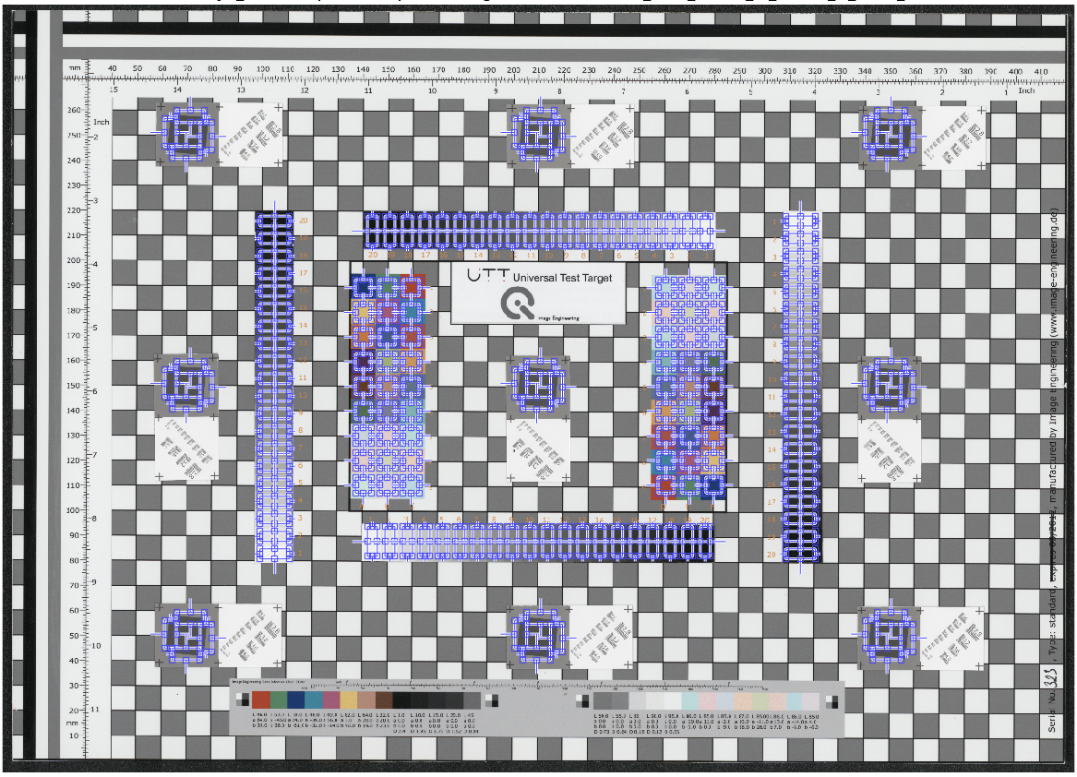

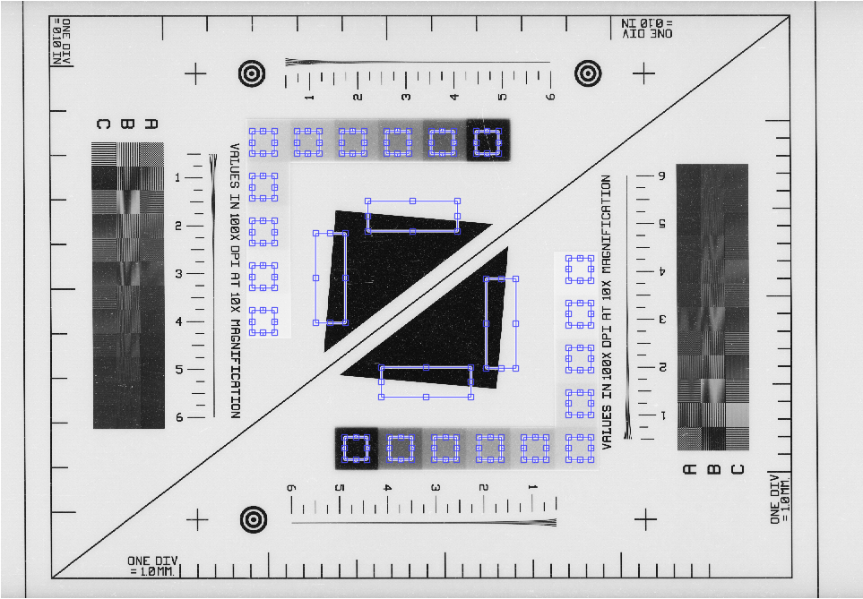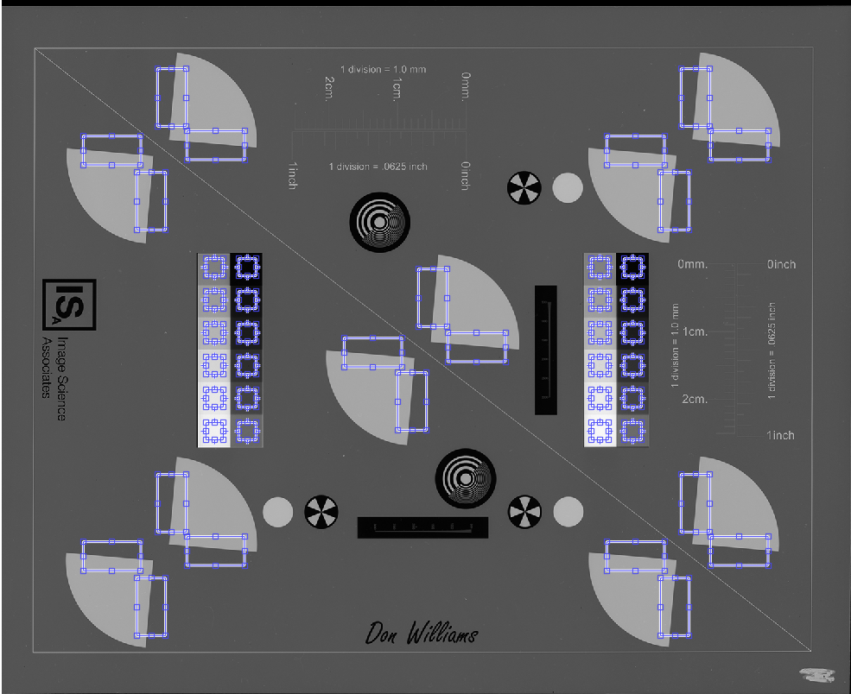

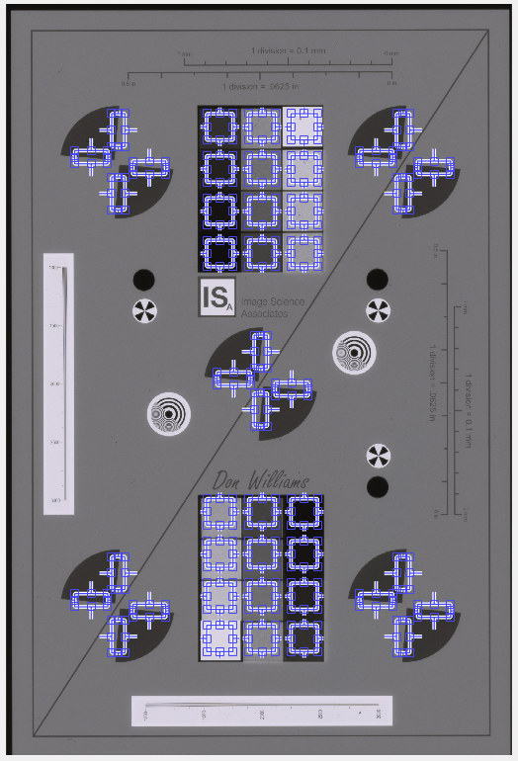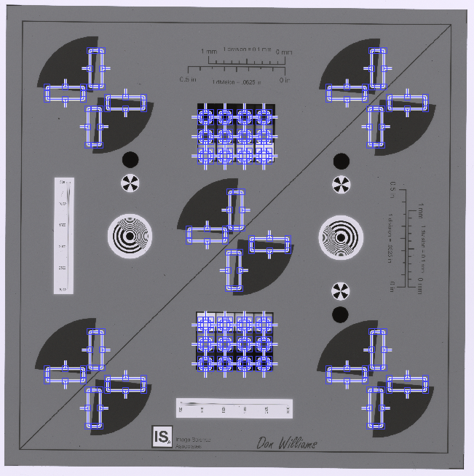
Figure 6. ROI identification for Colorchecker SG, DICE, Object DICE, NGT, IT8.7, UTT, Negative Small 35mm, Negative Large 4×5", Negative Small 35mm_2, and Negative Middle 120 target images.
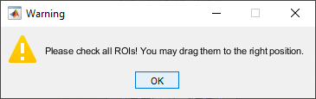
Once the ROIs are selected on the target image, a warning message will be presented to ask the user double check the locations of ROIs, which can be dragged to anywhere appropriate.
In case of a DICE or FADGI target with a 2D barcode, OpenDICE will try to scan the barcode and report that the measurements have been successfully replaced with the values encoded in the barcode.

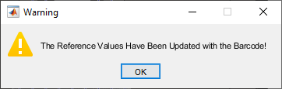

For the FADGI target, a dialog will be displayed for the target manufacturer measurements, see the screenshot below. Both the Excel and txt files can be downloaded from the FADGI website.

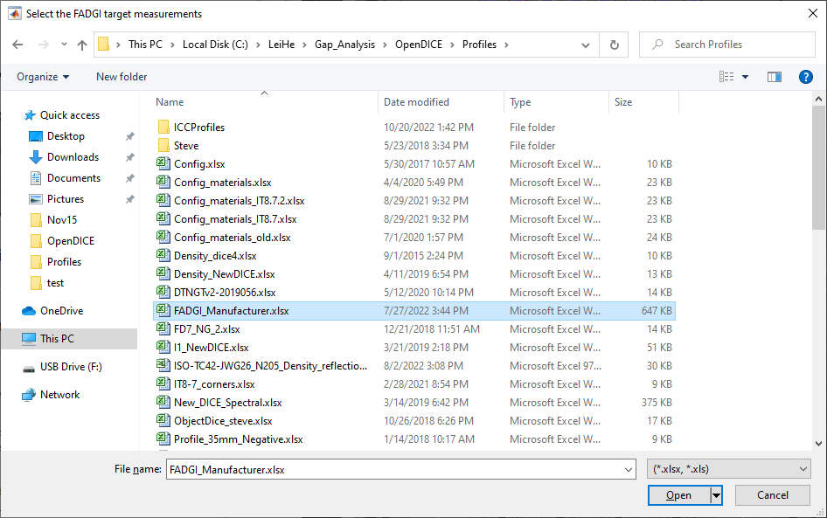

Step 6. Users confirm the ROI are acceptable, then click Run button to start assessment. The assessment results are displayed on two (Colorchecker SG target) or three (DICE target) windows.
Similarly for the FADGI Commercial target with 2D barcode, OpenDICE will detect the code and identify the serial number, which is then used to extract the manufacturer measurements from the Excel or text file.
For the Colorchecker SG target, the first window displays color accuracy analysis results and the second window presents tonescale analysis results. DICE target images have the third window for resolution analysis results.

(1). Color accuracy window consists of four tabs: Luminance, Delta E 2000, Color Registration Accuracy, and Summary.
Luminance tab shows the difference between the aim (ground truth from the measurements) and the actual image values for all patches, as shown in Figure 7.
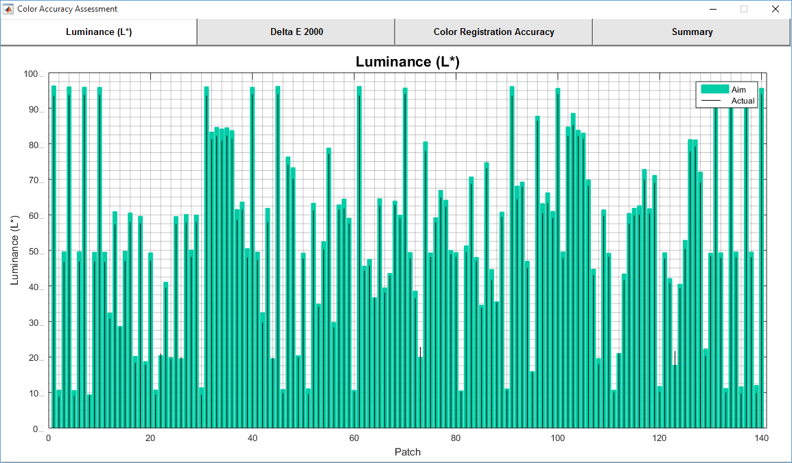
Figure 7. Luminance tab in Color Accuracy Analysis window

Delta E 2000 tab shows the ΔE2000 between the ground truth and the actual image values for all patches, as shown in Figure 8. The vertical black lines with black dots represent the actual ΔE2000 values, and the vertical red lines with red dots show the actual ΔE2000(a*b*) values. The horizontal magenta line shows the maximum upper limit for ΔE2000 according to the user FADGI level selection. Similarly, the horizontal blue line shows the mean upper limit for ΔE2000. The horizontal black line shows the actual mean ΔE2000, and the horizontal green line shows the actual median ΔE2000.
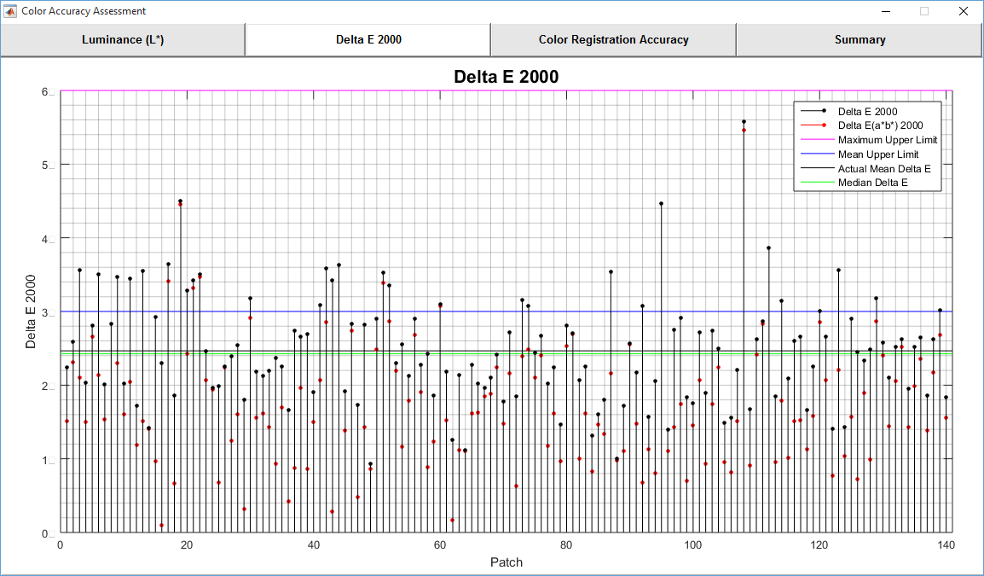
Figure 8. Delta E 2000 tab in Color Accuracy Analysis window

Color Registration Accuracy tab is not applicable to Colorchecker SG target. Figure 9 shows an example of DICE target.
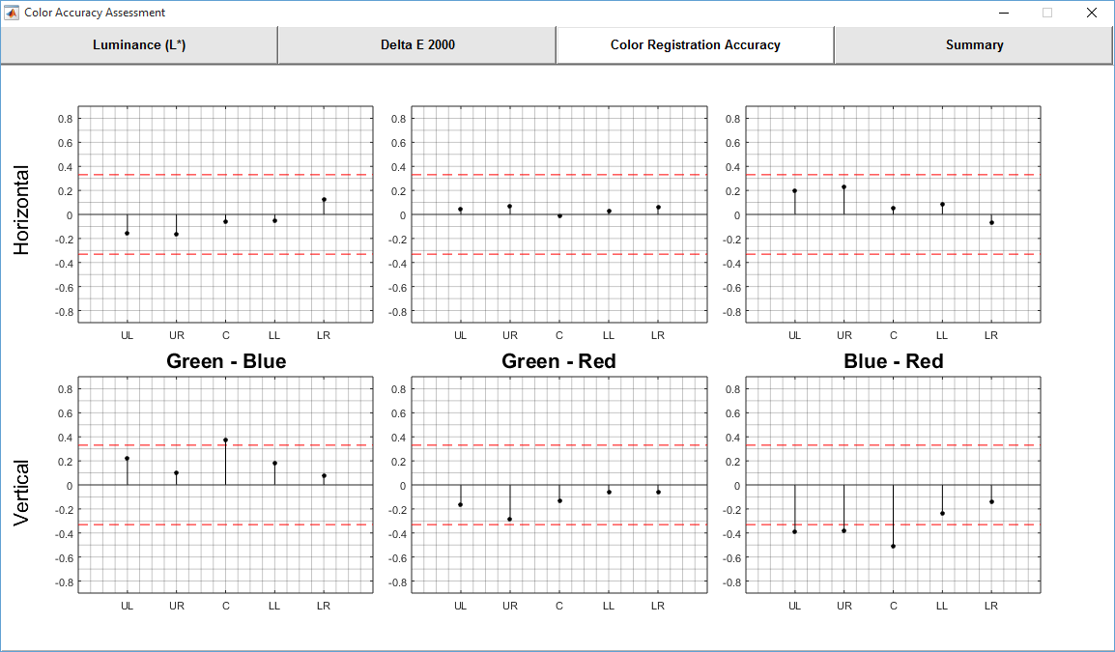
Figure 9. Color Registration Accuracy tab in Color Accuracy Analysis window (only for DICE target)

Summary tab shows the detail results (value) according to the FADGI guideline performance level (lower limit and upper limit), see Figure 10.
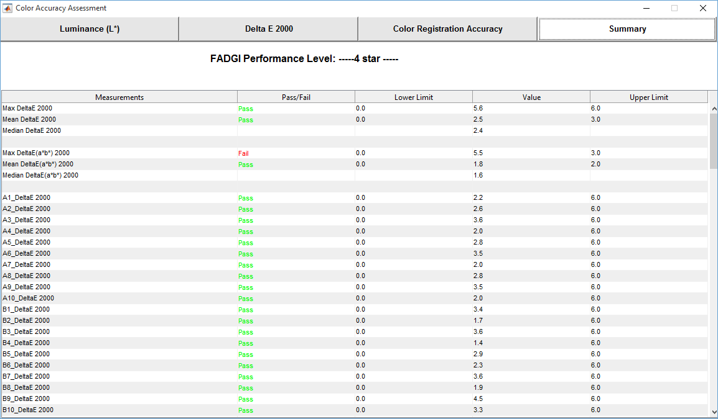
Figure 10. Summary tab in Color Accuracy Analysis window

(2). Tonescale analysis window consists of four tabs: OECF Curves, Difference to Aim, White Balance, Uniformity, Noise, and Summary.

OECF tab shows the OECF curves for RGB and luminance components, as shown in Figure 11. User may change the gamma, gain, and offset to adjust the curves in order to fit them into the range defined by the current FADGI level (magenta curves).
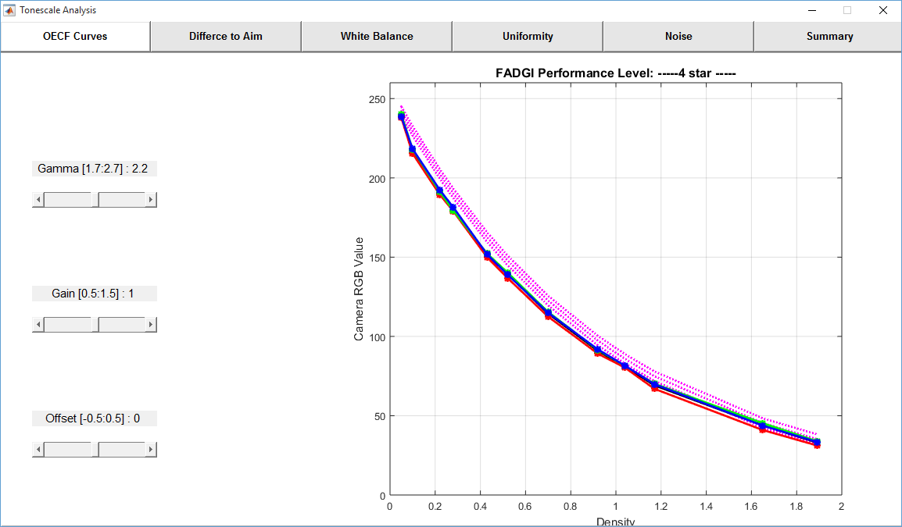
Figure 11. OECF Curves tab in Tonescale Analysis window

Difference to Aim tab shows error of the OECF curves, and the ideal range defined by the current FADGI level (magenta curves), see Figure 12.
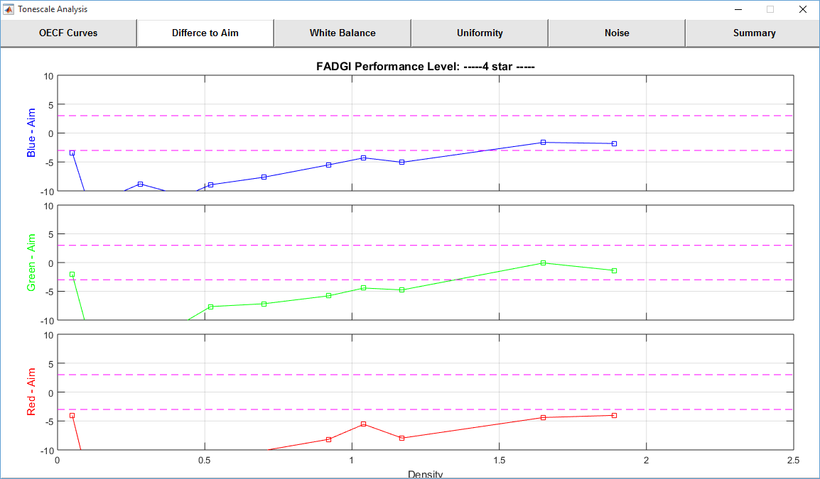
Figure 12. Difference to Aim tab shows the OECF curve errors in Tonescale Analysis window

White Balance tab shows white balance error (blue-red, green-red, and green-blue) of the neutral patches, and the ideal range defined by the current FADGI level (magenta curves), see Figure 13.
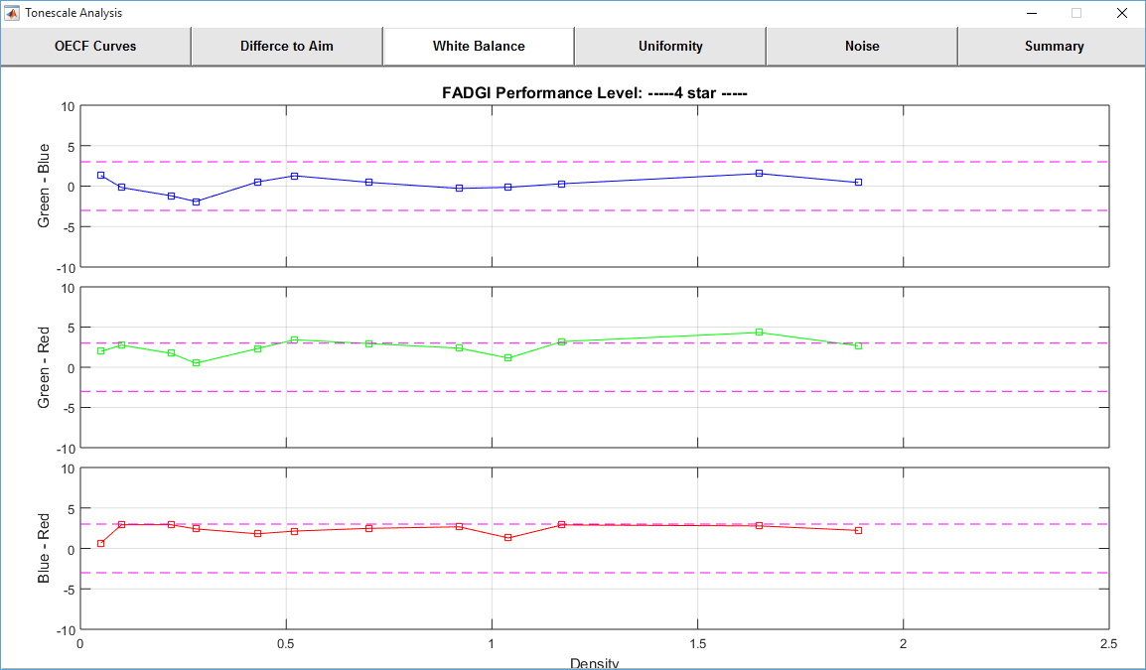
Figure 13. White Balance tab shows the white balance errors in Tonescale Analysis window

Uniformity assessment is not applicable to Colorchecker SG target. Figure 14 shows an example of DICE target.
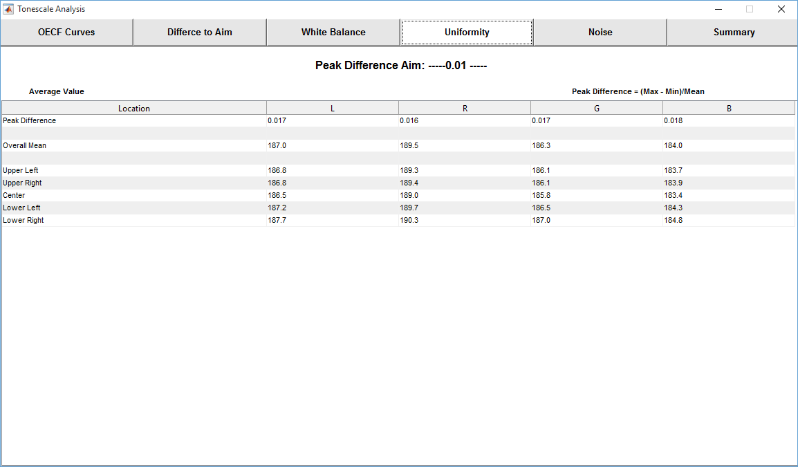
Figure 14. Uniformity tab shows the illuminance uniformity error in Tonescale Analysis window (only for DICE target)

Noise tab shows the noise level for the neutral patches, see Figure 15.
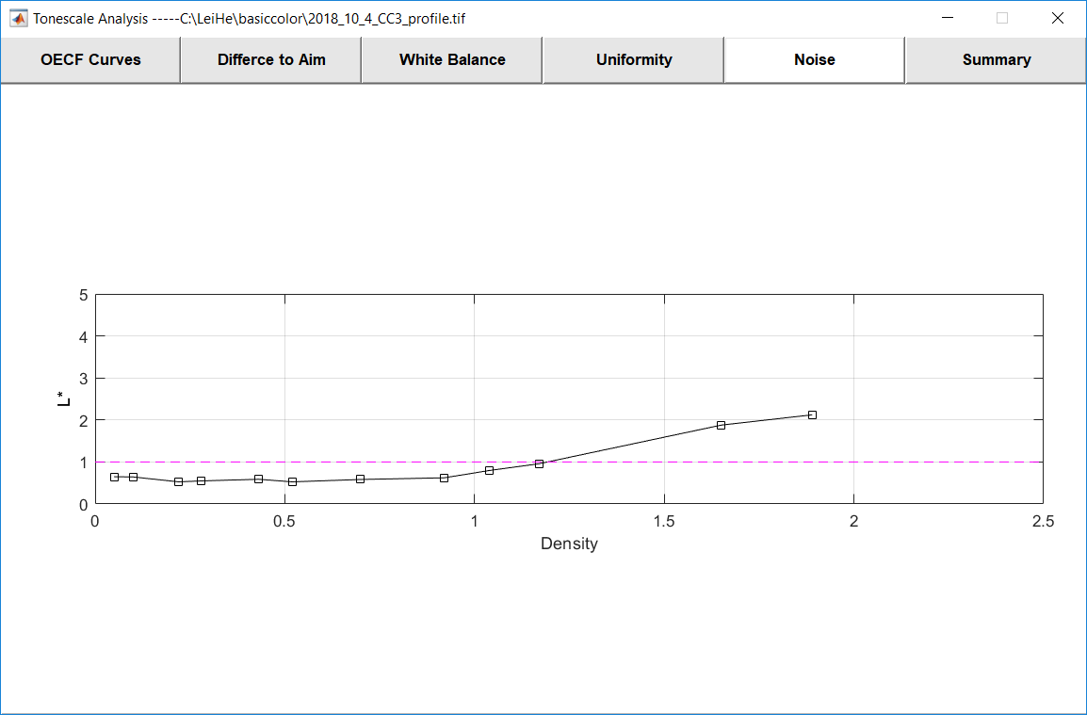
Figure 15. Noise tab shows the noise levels in Tonescale Analysis window

Summary tab shows the detail results (value) according to the FADGI guideline performance level (lower limit and upper limit), see Figure 16.
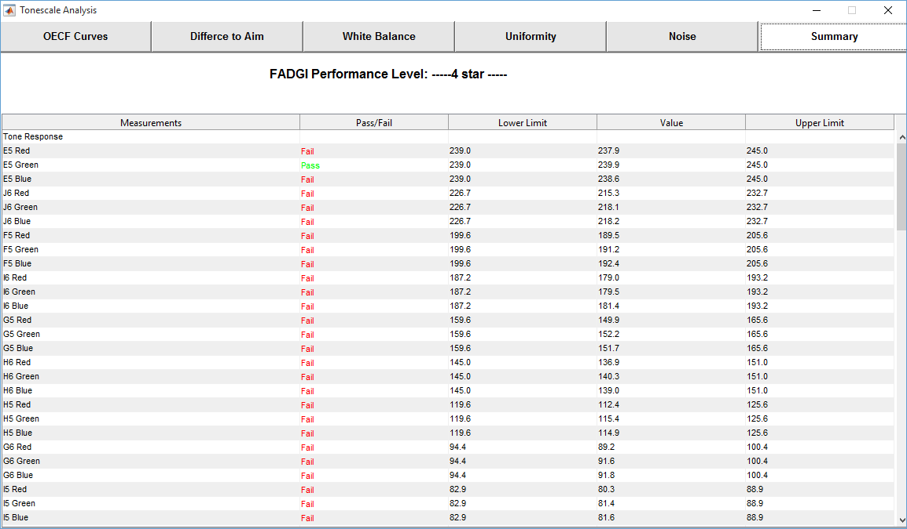
Figure 16. Summary tab shows the tonescale analysis results

(3). Specifically for DICE, UTT, and negative targets, there is a resolution analysis window which consists of nine tabs: Efficiency, SFR (10%), SFR (50%), Center, Upper Left, Upper Right, Lower Left, Lower Right, and Summary.

Efficiency tab shows the average sampling efficiency for red, green, and blue components, see Figure 17 and Figure 18.
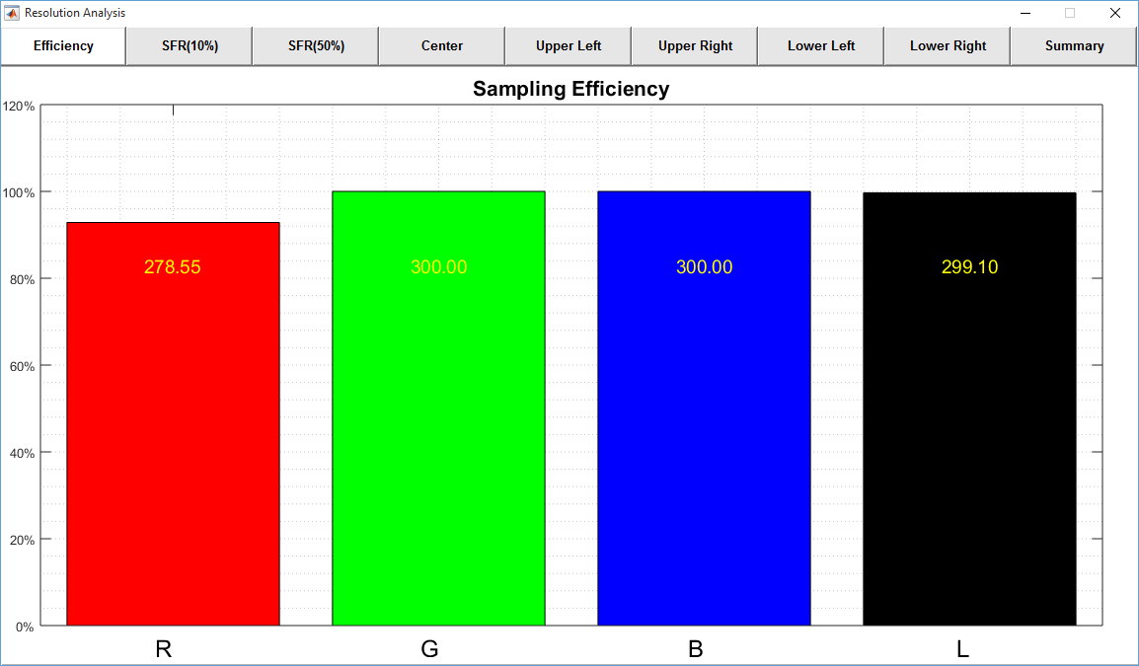
Figure 17. Efficiency tab shows the sampling efficiency values in resolution analysis window

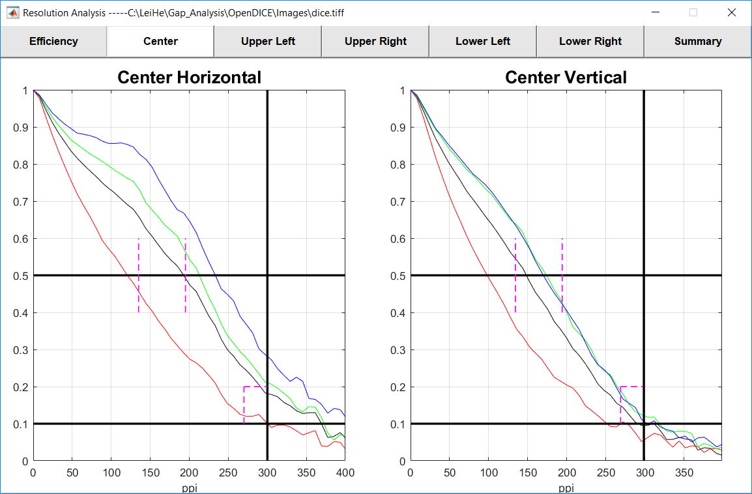
Figure 18. Sample SFR curve tab shows the frequency response at high and middle resolutions

Step 7. With these results, user may click the Export button to write all the results to an Excel or thee text files for all the resolution, color, and tonescale results. The file will be saved in the same folder as that of the image, with an extension of the FADGI star level. Note that Microsoft Excel is required in order to write the results.

