autoSFR Command Line (v1.0) User Manual
Lei He
lehe@loc.gov
1-202-707-8239

This is a command line version of the GUI-based autoSFR, which assesses the content resolution of a collection of sample images. The sample images are supposed to be collected with the same scanning resolution. The software requests two input:
autoSFRCommand “.\Samples\” “Config.xlsx”
The first input specifies the folder of images and the second input is an Excel file with all the parameters as below. The output is the scanning resolution, overall content sampling efficiency, and the content resolution.
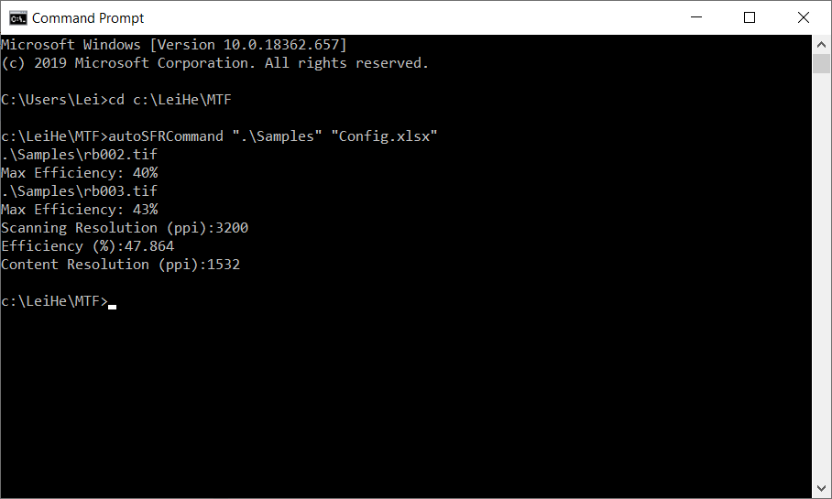

Here is a screen shot of the Samples folder:
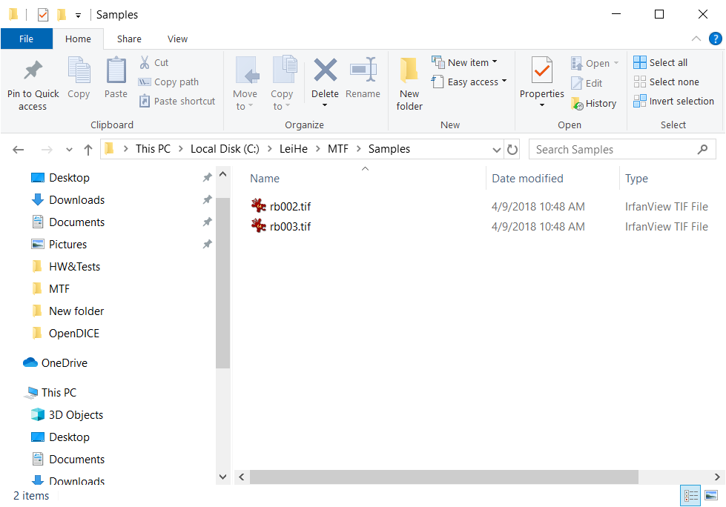
A sample of the Excel file is below:
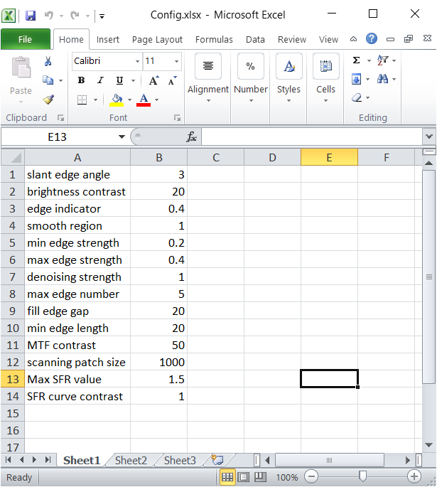

Edge Detection Parameter settings:
Scanning Patch Size: the software analyzes the images block by block in order to overcome the inhomogeneous intensity and noise problems, and to reduce the processing time cost. This parameter refers to the block size. Depending on the input image size, users can change it to smaller (500 by 500) or larger size (2000 by 2000).
Slant Edge Angle determines the acceptable edge slope. The angle is measured with respect to both vertical and horizontal axis, i.e., the edge orientation can be either direction.
Brightness Contrast determines the average intensity difference between the regions at the two sides of the detected edges. The larger this number, the larger the difference.
Edge Indicator is the threshold that determines if the current block contains sufficient edges. The larger this number, the higher the threshold to accept the current block for analysis.
Smooth Region is the threshold that determines if the current edge region is smooth enough or not. For a detected edge, its surrounding region should be smooth. The larger this number, the lower the threshold to accept the edge region for analysis.
Fill Edge Gap determines the largest gap between two detected edge segments. For any two edge segments, if they have the same orientation and have a gap smaller than this number, then they will be connected to be one edge segment.
Min Edge Strength determines the lower threshold in Canny edge detector. The smaller this number, the more edge segments are detected.
Max Edge Strength determines the higher threshold in Canny edge detector. The smaller this number, the more edge segments are discarded. This number should be always larger than the Min Edge Strength.
Denoising Strength determines the variance of the Gaussian filter that smooths the block before edge detection. If the input image is too noisy, then a larger number (e.g., 3) should be used to detect more edge candidates.
Max Edge # determines the number of candidate edges in current block.
Min Edge Length determines the acceptable smallest edge length.
SFR Computation Parameter settings:
MTF Contrast indicates the contrast between the maximum low frequency MTF and high frequency MTF. The larger the number, the larger the difference will be accepted.
SFR Curve Contrast indicates the contrast between the mean MTF of the low and high frequency components. The larger the number, the larger the difference will be accepted.
Max SFR Value determines the allowed largest MTF value in the low frequency component.

