OpenDICE Command Line (v2.6) User Manual
Lei He
lehe@loc.gov
1-202-707-8239

This version of OpenDICE implements the FADGI v2016. It is a command line version of the GUI-based OpenDICE v2.6. Based on the v2.5, this version adds the bar code support to the FADGI 19264 target.
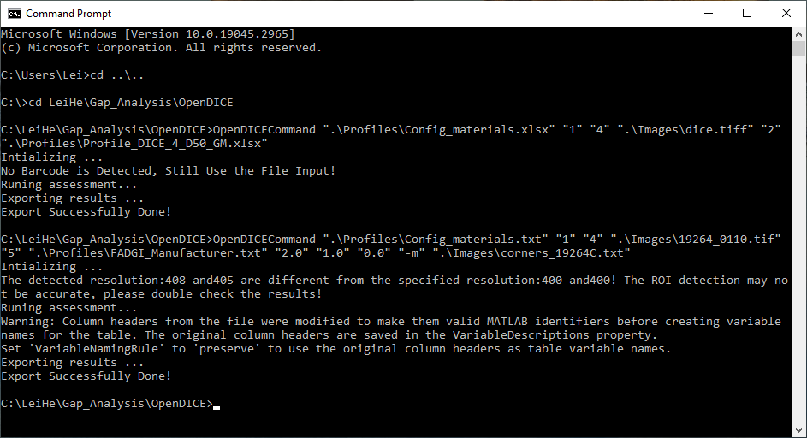
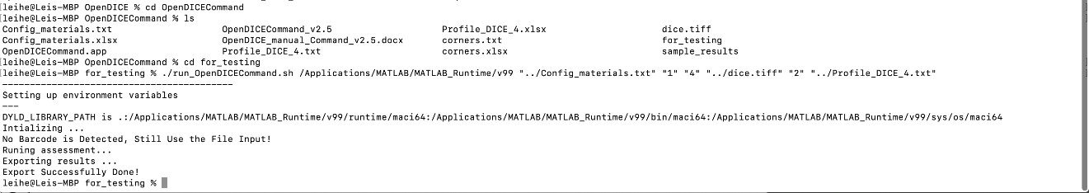
Figure 1. OpenDICE command line version (Windows and Mac)

In the interface (Figure 1), the command line consists of the software name, OpenDICECommand, and a set of parameters:

- Material specifications (Config_materials.xlsx), please refer the GUI version manual.

- Material selection (specified with a numeric value)
Bound Volumes: General Collections ----------------------------------------------------1
Bound Volumes: Rare and Special Materials--------------------------------------------2
Documents (Unbound): General Collections --------------------------------------------3
Documents (Unbound): Manuscripts and Other Rare and Special Materials ------4
Oversize Items: Maps, Posters, and Other Materials -----------------------------------5
Newspapers ----------------------------------------------------------------------------------6
Prints and Photographs ---------------------------------------------------------------------7
Paintings and Other Two-Dimensional Art (other than prints) -----------------------8
Photographic Transparencies: 35mm to 4"x5" ------------------------------------------9
Photographic Transparencies: >4"x5" ----------------------------------------------------10
Photographic Negatives: 35mm to 4"x5" -----------------------------------------------11
Photographic Negatives: > 4"x5" --------------------------------------------------------12
X-ray Film: (Radiographs) ----------------------------------------------------------------13
Printed Matter, Manuscripts, and Other Documents on Microfilm ------------------14

- FADGI star criteria selection (specified with a numeric value):
* (1); ** 2; *** (3); **** (4)
4. Target image name (dice.tiff)
5. For the target options (specified with a numeric value):
ColorChecker SG ----------------------------------------------------------------------------1
DICE ------------------------------------------------------------------------------------------2
ObjectDICE(small) --------------------------------------------------------------------------3
FADGI 19264 --------------------------------------------------------------------------------4
FADGI 19264 Commercial ----------------------------------------------------------------5
NGT (manual) -------------------------------------------------------------------------------6
DT-NGT --------------------------------------------------------------------------------------7
IT8.7/2 (manual) -----------------------------------------------------------------------------8
UTT ----------------------------------------------------------------------------------------9
Negative/Positive Small 35mm ------------------------------------------------------------10
Negative Large 4x5 --------------------------------------------------------------------------11
Negative Small 35mm 2 ---------------------------------------------------------------------12
Negative Middle 120x120 -------------------------------------------------------------------13
IT8.7/1 (manual) ------------------------------------------------------------------------------14
6. Target profile name (Profile_DICE_4_D50_GM.xlsx), please refer the GUI version manual.

The above six parameters are required! For the FADGI 19264 Commercial target, the target profile name is replaced by the FADGI_Manufactuer.xlsx/txt for the collection of all measurements provided by the manufacturer.
The following parameters are optional, but some of them must be specified together, i.e., they cannot be used individually.

7. Tonescale assessment parameters (3 parameters specified in the following order as numeric values):
Gamma (2.2), Gain (1.0), Offset (0)
8. Export results (-e)
If not specified, then the software exports only luminance results; if it’s specified, then all RGB components will be exported.
9. Manual ROI detection parameters (-o corners.xlsx)
For more accurate results or fast processing, this option is recommended! An example with four corner points is specified as following:
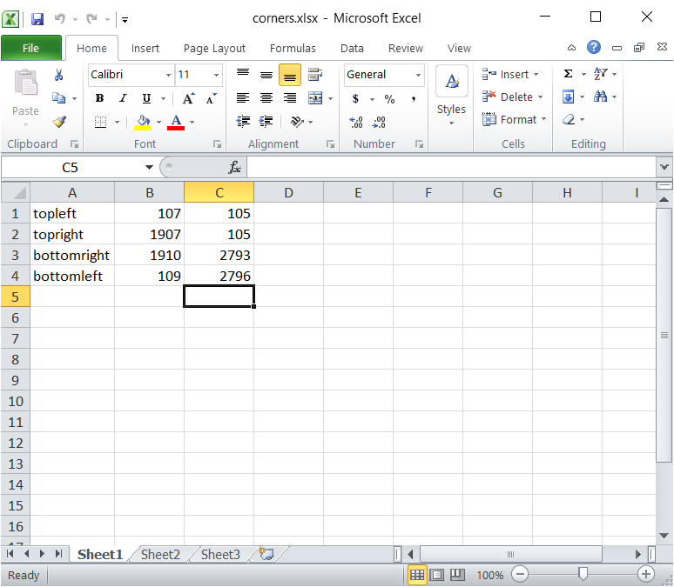

The software exports the results as the GUI-based version in an Excel file.
